

**Zara Therapy Clinic**

**Supervisor:** Ms. Nguyễn Hạ Vy

**Semester:** 01

**Batch No:** T1.2302.M0

**Group No:** 04

|  |  |  |
| --- | --- | --- |
| **Order** | **Full name** | **Roll Number** |
| 1 | Đặng Quốc Bảo | Student1455777 |
| 2 | Huỳnh Bội Sương | Student1448255 |
| 3 | Nguyễn Công Hiển | Student1448341 |
| 4 | Nguyễn Thùy Trang | Student1455775 |

**Month**: 5 **Year**: 2023

**This report is to certify that four of us:**

* Đặng Quốc Bảo
* Huỳnh Bội Sương
* Nguyễn Công Hiển
* Nguyễn Thùy Trang

**Have successfully Designed and Developed:**

**Zara Therapy Clinic**

**Submitted by:** Ms. Nguyễn Hạ Vy

**Date of Issue:** 5/15/2023

**TABLE OF CONTENT**

**Acknowledgement** 4

**Synopsis** 5

*Abstract:* 5

*Introduction:* 6

*Objectives:* 6

*Methodology and methods:* 6

*References:* 7

**Analysis** 10

**Design** 15

Data Flow Diagrams 15

Flowcharts 16

Site Map 20

Process Diagrams 20

Wire Frame 21

**User Guide** 25

**Module Descriptions** 43

**Conclusion** 46

# **Acknowledgement**

First and foremost, it is hard to say that this is the end of the Zara Therapy Clinic project. It was one of the most challenging yet delightful experiences in our educational career. We put lots of effort to make a good project with our full commitment and responsibility.

Even though it has been a long and strenuous project, we have done it with the support and guidance from our lovely teacher Ms. Vy Nguyen Ha so we would like to acknowledge with thanks to her for all the valuable suggestions with this project as well as all FPT Aptech professors who gave us the golden opportunity to design this wonderful project on the topic Zara Therapy Clinic, which also helped us in doing a lot of researches and we came to know about so many new things we greatly appreciate them.

Lastly, thanks again to everyone involved in making it happen because without them we would not be here today with an amazing website completed!

Sincerely,

Dang Quoc Bao

Huynh Boi Suong

Nguyen Cong Hien

Nguyen Thuy Trang

T1.2302.M0

# **Synopsis**

## *Abstract:*

As the World Health Organization, depression is one of the most common mental disorders in the world. Besides, it is estimated that 5% of adults endure the disorder. As a result, Vietnamese people require therapeutic support with the constantly rising graph of Vietnam’s mental health concerns. Moreover, a meta-analysis of 27,216 selected participants shows that the pooled prevalence of depression was 14.636% (95% CI: 11.521–18.054% I2 = 97.98% P < 0.0001). In 2022, there was a total of 11,448 traffic accidents occurred and 31 traffic accidents per day in Vietnam which claimed 17 lives and injured 22 people based on the average. Based on the list of seven most dangerous places in the world for tourists to drive, Vietnam is on the fourth according to the data analytics research company named The Swiftest. According to Ministry of Health statistics, 30 per cent of the country’s population suffer from the lumbar disc herniation included many aged between 25 and 55, the patients choose a physical therapy instead of surgery even if severe. Therefore, we not only need to care about the mental disorders’ outbreak but also bring Zara Therapy Clinic to our lovely customers by offering the comfortable massage services and assisting them with physiotherapy in order to help them gradually getting well. In another aspect, we understand that online marketing could help establishing a strong online presence, making it easier for patients to find our clinic when searching for relevant keywords and phrases. Social media marketing is more popular nowadays and it can also be used to intensify online visibility as well as to allow our therapy clinic connecting with patients on platforms where they spend most of their time in order to build long-term relationships with them all the time. Digital marketing strategies can help our therapy clinic to proactively manage online reputation likewise to maintain a positive image through respond to any reviews and engage with patients to address any concerns they may have. Moreover, as we compare to traditional marketing methods, digital marketing is a cost-effective way for our clinic to market our services and products. We can also reach out to potential patients leading to a higher return on investment for our marketing efforts. Realizing some potentials of online marketing as shown above, we launched a website to provide more experiences and information about our therapy clinic's services and products to customers.

## *Introduction:*

We help every customer relieve stress, increase relaxation, improve circulation, and gain relief from pain by manipulating the muscle and tissues in the body at Zara Therapy Clinic. Besides that, we also provide collections of products with advisable costs. Here we have the best doctors and employees helping rehabilitate injuries through touch and aid in the general wellness of a patient.

Getting a website built for the respective services is one of the most important marketing tasks that need to complete. Despite a website by itself will not bring new customers to our clinic, it will not be easy to generate new clients online without an appropriately website strategy. Once a website strategy is decently developed, search engine optimization and advertisement can be used to expand our business for long-standing success. Thus, we evolve a sample website for any therapy clinic which will provide complete details about the services and products, educational information as well.

## *Objectives:*

This program's purpose is to give one sampling project to work on real life projects. These applications guide us to build a larger and prosperous application. We are not aiming to study only the HTML/JavaScript/Dreamweaver/HTML5 but to obtain a drill with a real-life scenario and create basic applications using the tools that we have learned through sessions. It is a long path to reach out to this project after the completion of the HTML5's module.

## *Methodology and methods:*

We use the hardware as below:

* Intel Core i3/i5 Processor or higher
* 8 GB RAM or above
* Color SVGA
* 500 GB Hard Disk space
* Mouse
* Keyboard

We use some of the software as below:

* + Technologies to be used:
  + Frontend: HTML5, CSS, Bootstrap, JavaScript, jQuery, AngularJS, XML
  + Data Store: JSON files or TXT files
  + Other Requirements:
  + Operating Portal: Windows
  + Browsers: Edge, Chrome, Mozilla Firefox, Safari

Libraries that we used while coding:

* Google Web Fonts
* Angular
* Bootstrap
* Font Awesome
* Animate
* jQuery

## *References:*

Fizio F.L.Y. (n.d.). Chiropractic Therapy. https://www.fiziofly.hr/services/chiropractic-therpay/

Haines, Anna. (2022, May 31). Everything You Need To Know About Acupuncture. <https://www.forbes.com/sites/annahaines/2022/05/31/everything-you-need-to-know-about-acupuncture/?sh=30d7a709783c>

Hoang, Phong. (2022, December 17). Vietnam driving ranked among most dangerous for tourists. https://e.vnexpress.net/news/travel/vietnam-driving-ranked-among-most-dangerous-for-tourists-4549280.html

Legal Line. (n.d.). Slip, Trip and Fall: Who can you sue? https://www.legalline.ca/legal-answers/slip-and-fall-who-can-you-sue/#:~:text=If%20you%20fall%20and%20injure,or%20city%2C%20or%20a%20neighbour.

Livingston, Mercey. (2020, February 21). Acupuncture: Everything you need to know before you try it. https://www.cnet.com/health/what-you-need-to-know-before-you-try-acupuncture/

Mayo Clinic. (n.d.). https://www.mayoclinic.org/

Medical News Today. (2017, June 22). Everything you need to know about osteopathy. https://www.medicalnewstoday.com/articles/70381

National Center for Complementary and Integrative Health. (n.d.). Massage Therapy: What You Need To Know. https://www.nccih.nih.gov/health/massage-therapy-what-you-need-to-know#:~:text=Massage%20therapy%20is%20used%20to,to%20try%20to%20relieve%20pain.

National Library of Medicine. (2020, August 27). Physical therapy. https://www.ncbi.nlm.nih.gov/books/NBK561514/#:~:text=The%20aim%20of%20physical%20therapy,to%20improve%20their%20own%20health.

Phan, Ngoc Quang & Tran, Quang Duc & Vu, Thi Quynh Chi. (2022, June 3). Depression prevalence in Vietnam during the Covid-19 pandemic: A systematic review and meta-analysis. https://www.ncbi.nlm.nih.gov/pmc/articles/PMC9162960/#:~:text=Among%20eligible%20studies%20the%20pooled,18.054%25%20and%2013%20studies).

Physio Health Zara Rehab. (n.d.). https://physiohealthzararehab.com/

Private Therapy Clinic. (n.d.). https://theprivatetherapyclinic.co.uk/

South Centre Chiropractic Clinic & Summerside Chiropractic. (2017, September 20). 6 Benefits of Chiropractic Care on Wellness. https://www.southedmontonchiropractor.com/blog/posts/6-benefits-of-chiropractic-care-on-wellness

Viet Nam News. (2021, June 24). More and more young people suffer from lumbar disc herniation. https://vietnamnews.vn/society/979372/more-and-more-young-people-suffer-from-lumbar-disc-herniation.html

World Health Organization. (n.d.). Depression. https://www.who.int/health-topics/depression#tab=tab_1

Xinhuanet. (2022, December 30). Nearly 6,400 people die due to traffic accidents in Vietnam in 2022. https://english.news.cn/20221230/468116d47bd64ea4bf1c7e8978d2c711/c.html#:~:text=On%20average%2C%20in%202022%2C%20Vietnam,lives%20and%20injured%2022%20people.

Zara Clinic. (n.d.). <http://zaravancouver.com/index.html>

# **Analysis**

*Purpose of Zara Therapy Clinic Website Usage:*

In this modern era, rehabilitation physiotherapy has become one of the most common therapies and widely applied treatment method in the treatment of many pathologies. With its safety and efficacy, it has helped millions of people around the world recover their health and quality of life. However, not everyone has a clear understanding of physical therapy and rehabilitation are, and when they should be applied. Therefore, Zara Therapy Clinic decided to design a website in order to provide information and knowledge for customers to keep in touch with them.

Our website is not only a way to promote our services and products, but also a valuable educational resource. We want to bring information about rehabilitation therapy closer to people, helping them understand its benefits and how to apply it to take care of themselves in daily life. We believe that by the work of providing complete and detailed knowledge, we can help people make informed decisions about which therapy is the most appropriate for them.

Not merely providing information, we also want to contribute to reducing the burden of disease on people and building a happy and healthy community. By encouraging people to use our website, we provide convenient online appointment booking, without the need to visit the clinic. This saves our clients time and effort and ensures that they obtain the best care and treatment from our team of specialists.

In addition, customers can take the initiative to call or receive online consultations from our own website whenever they cannot reach our clinic. Our team of experienced professionals will always be happy to listen and answer any questions and support requests from our customers. We understand that recovery and treatment can be difficult at times, and so we want to be with our clients and make sure they don't face these challenges alone.

At Zara Therapy Clinic, we are committed to catering the best care to our clients. Our website will connect between us and our customers, helping us to afford the best information and support as best as we can. We believe that by creating a high-quality online resource, we can contribute to improving people's health and quality of life.

Our website has been designed with a friendly and easy to use interface. We have optimized the operations so that customers can easily find information, book appointments, and interact with our team of experts. By leveraging technology and online communication, we want to ensure that people can approach rehabilitation therapy services in the most convenient and flexible way.

On the website, clients can learn about diseases and problems related to rehabilitation therapy. Zara Therapy Clinic’s website provides information on therapeutic methods and techniques, as well as the benefits they provide. Customers can learn about the recovery process, exercises, and techniques, as well as self-care measures at home. We provide educational materials, videos, and articles to help clients have clearer sight about rehabilitation therapy and apply it to their daily lives.

Farther, our website also meets customers' online consulting needs. Customers can interact directly with our experts through online chat or video call. Our team of experts will listen to all the customers’ inquiries and request support and provide applicable advice and guidance. We believe this face-to-face interaction will help clients feel more confident and reliable during their recovery and treatment.

Our website also offers the convenience of online appointment scheduling. Customers can choose a suitable date and time for their schedule and book appointments online hands down. This saves time and effort for our customers while ensuring they receive the best care and treatment from our expert team.

In conclusion, not to mention that our website is not just a tool for promoting our services, it brings valuable educational and support resources to all the customers as well. We aim to provide detailed and understandable knowledge and information about functional rehabilitation. Through our website, we hope to accompany customers throughout their recovery journey and bring them a better quality of life.

*Target Customer Segment:*

Regardless of age, we always aim to serve everybody as much as possible. Physical therapy is a treatment method that can be applied to anyone, depending on the regimen and method prescribed by a doctor. Nevertheless, according to the elderly population in Vietnam, many people are still unaware of the benefits of physical therapy, and just a few numbers of people are using the internet to look up more information about it. Thus, the primary target group we are focusing on is individuals aged 35 to 50 (middle-aged). This group of people is capable of quickly using the internet and accessing information through the PR and marketing campaigns we deploy. In particular, they tend to seek deeper understanding to improve their own and their family's health.

For each age group, we will provide tailored treatment protocols, combined with one-by-one individual therapy sessions conducted by expert doctors. In this way, we ensure that patients receive dedicated care and recover their health quickly.

At Zara Therapy Clinic, we are committed to provide quality and attentive services to all customers, especially those in the middle age. We understand that the modern life causes many pressures and challenges to our health. The expert team at the clinic will find optimal solutions to recover their body functions and help customers thrive in their daily lives by combining specialized knowledge and practical experience.

We hope that our website will be a useful and reliable source of information for this target group of customers. By accessing the website, customers can learn about the types of therapies we provide, supportive products, and efficiently schedule appointments online. In addition, we offer telephone consultating services directly from the website, to help our customers get in touch with our employees besides additional support and have the privilege to get their questions answered.

With a mission of sharing the burden of illness and contribute to the development of family happiness and social well-being, we hope to be a reliable partner in everyone's healthcare path, especially the middle-aged group, to build a healthy and prosperous community together. If you look through the feedback section on the website, you will see that we already served people of various ages, from babies and children to the elderly. Therefore, we are proud of our ability to diagnose and treat everyone.

With this principle, we are ready to accompany everyone, not only to provide the best services but also to create a safe and comfortable environment. We hope to have the opportunity to accompany and support you on your journey to healthy recovery and improving the quality of life.

*Comparison of Our One-of-a-kind Website with Others:*

Our website stands out from other websites with the aim of providing the best experience for our customers. In the clinics and therapy field, there is often a tendency to focus on offline activities, disregard the importance of the online environment and online services. However, we have noticed that customers have an increasing demand for using online services and searching for information on the internet.

A common issue that other websites often encounter is a difficult and user-unfriendly interface. For those who are not familiar with technology or do not have in-depth knowledge of therapy, using online services becomes challenging and confronts many obstacles. That is why we prioritize optimizing the user experience when designing our website.

With our website, customers can easily access the services and information we provide. We have created a friendly and intuitive interface, helping customers quickly and easily search for information. They can learn about the therapy services we offer, view detailed information about products, and easily place online orders without visiting the clinic by their own selves.

In particular, we provide online counseling services, allowing customers to access our therapy experts directly on the website. They can ask questions, receive advice, and get answers to their inquiries quickly and conveniently. This helps our customers feel reassured and trustfully when using our services, and they can receive professional support and right caring from their homes.

Not only does our website save customers time and effort, but it also provides detailed information about related illnesses and treatment methods. This helps customers have a better understanding of their health conditions and choose appropriate treatment methods. We always ensure that the information provided on our website is accurate and easy to understand, helping customers make informed decisions about their health.

By investing the website and online services, we hope to bring convenience and the best experience to our customers. We are committed to continuously improving and developing our website while listening to feedback and suggestions from customers to gradually upgrade our clinic. We believe that with the combination of technology and healthcare, we can contribute to improve the quality of life and health for everyone.

In short, our website aims to not only provide the best online information and services for customers but also create a connection between the clinic and therapy field with the online environment. We understand that the development of technology and the internet has changed how we access information and healthcare services. Therefore, we constantly strive to enhance the user experience and meet all customer needs.

Through establishing the website and online services, we hope to bring convenience and the best experience to customers in learning about therapy and health care. We are committed to continuous improvement and development of our website while listening to feedback and suggestions from customers to become even better.

We believe that the combination of technology and healthcare is an important step in the modern medical industry. By harnessing the potential of the online environment, we aspire to contribute to improving the quality of life and health in order to create a better life for everyone. With the companionship and trust of customers, we will continue to innovate and develop with the desire to become a reliable and preferred choice in the field of online clinics and therapy.

Thanks to our customers accompanying us, and we look forward to serving and supporting them on their healthcare and therapy pathway. Kindly visit our website to explore and experience the utilities and benefits that we bring. We are committed to follow every client in accordance with the wellness program and improving their health.

# **Design**

## Data Flow Diagrams

These data flow diagrams (DFD) draw out the flow of information for any system or process and illustrate a detailed representation of system components. The below DFD’s will bring a clearer picture of Zara Therapy Clinic website in order to let technical and nontechnical audiences effortless to understand it. Moreover, DFD’s support the logic behind the data flow within the system. Data flow diagrams also aid in describing the boundaries of our website’s system and exchange the ideas and existing system knowledge to the users.

*Zero Level DFD – Context Diagram: Illustration of a basic overview of the Zara Therapy Clinic’s whole system as well as a designation of an at-a-glance view*

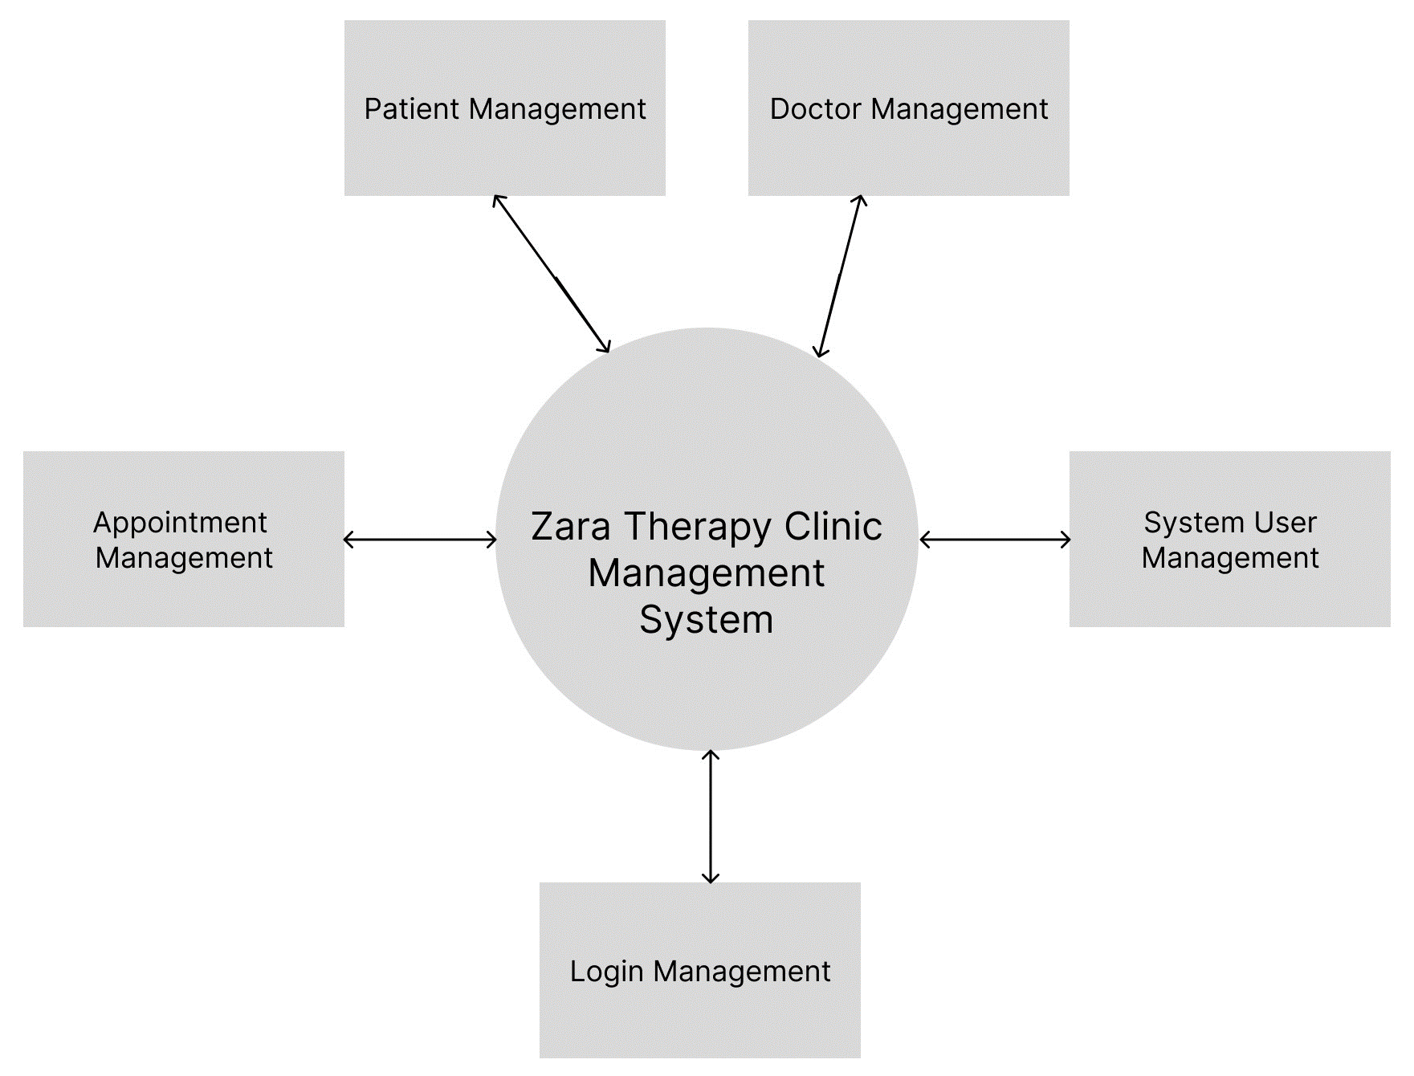

*First Level DFD: provides a more detailed view of our system by analyzing the major processes identified in the Zero Level DFD into sub-processes*

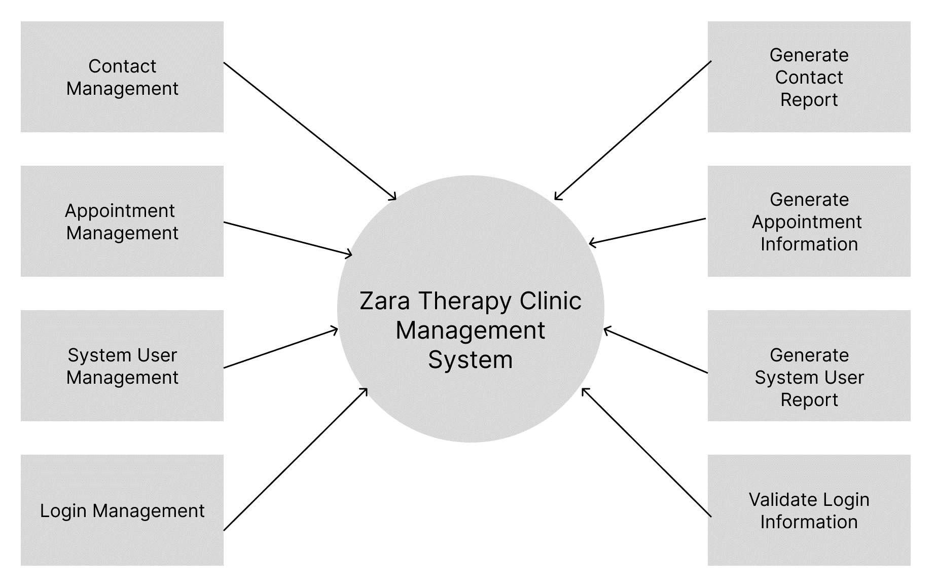

*Second Level of DFD: arranges more detailed view of Zara Therapy Clinic website’s system*

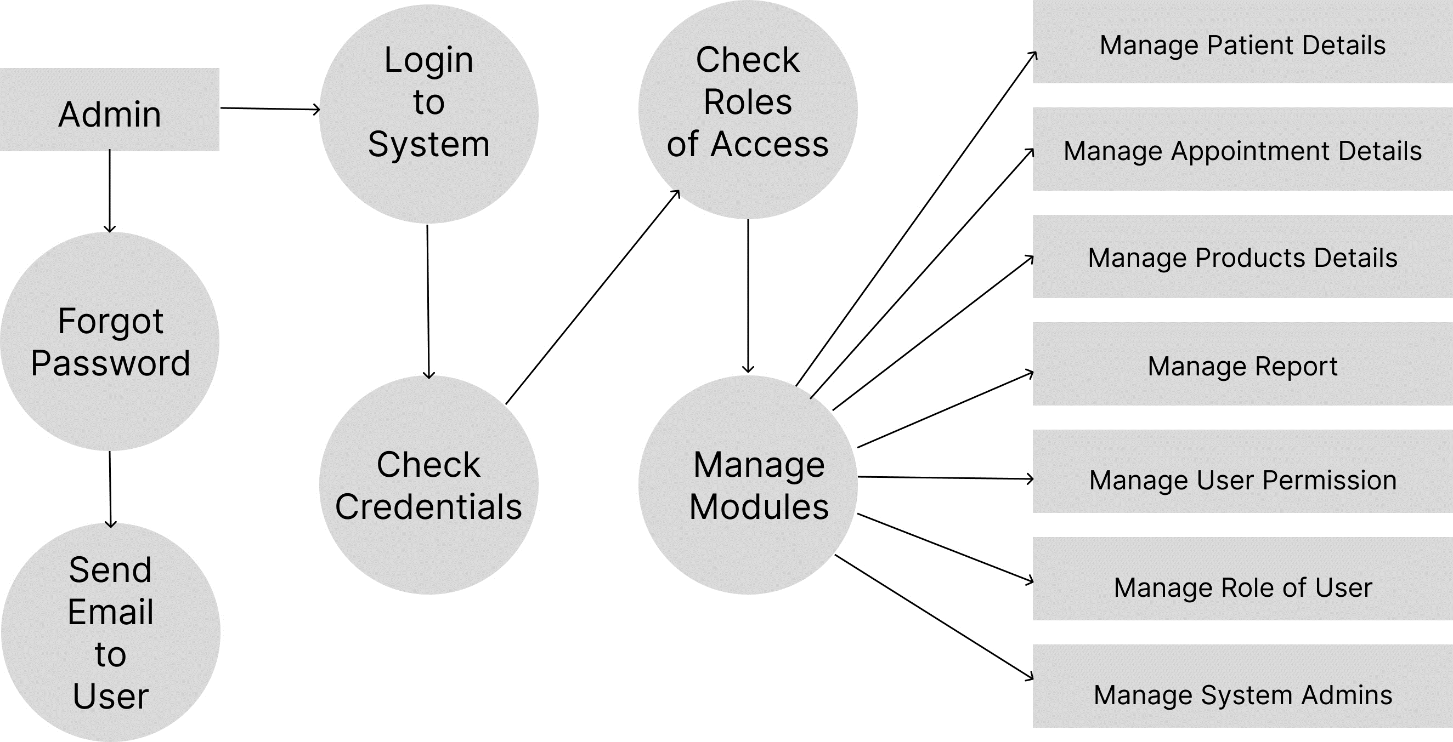

## Flowcharts

Drawing flowcharts for our website brought us many important benefits and a clear sight of this eProject. First, it helps us better understanding how the site works and find weak points that need improvement. Second, flowcharts optimize the user experience by shaping the flow that leads to the user's goals and ensuring there will be no error on the users’ side. Third, it improves internal workflow and enhances communication within the team. Finally, flowcharts provide a simple and intuitive means of communication for expressing opinions and suggestions. With the use of flowcharts, we create a consistent website, control quality, and increase productivity.

*About us page usage guidance:*

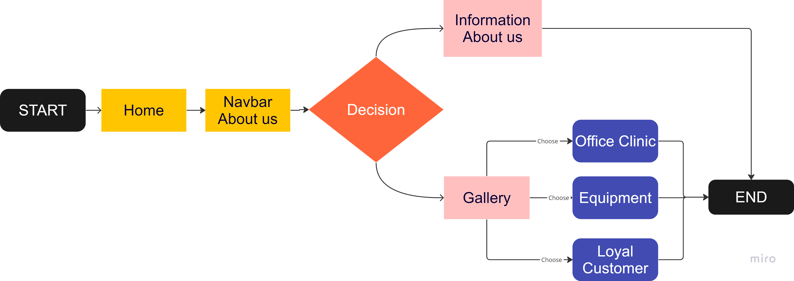

*Services page usage guidance:*

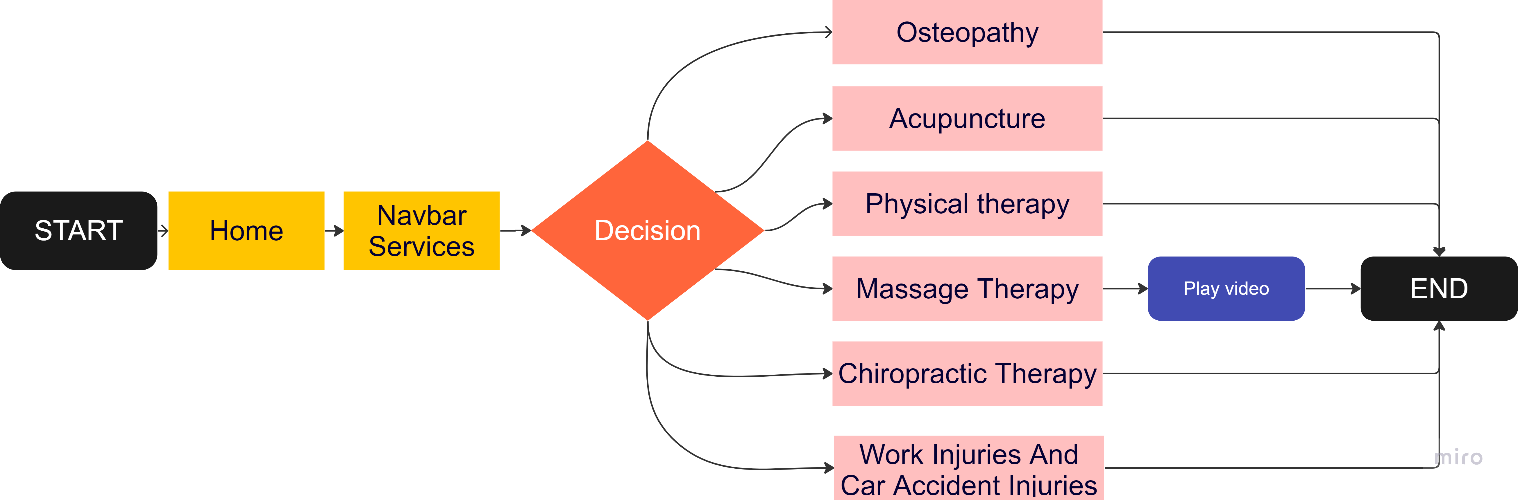

*Products page usage guidance:*

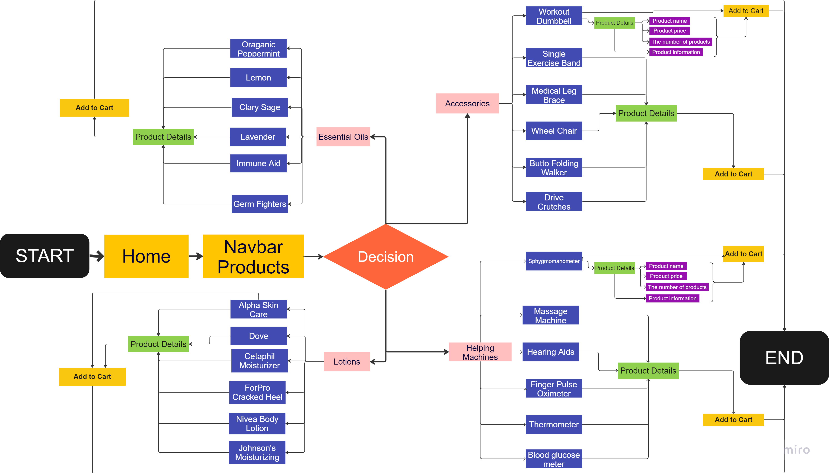

*News page usage guidance:*

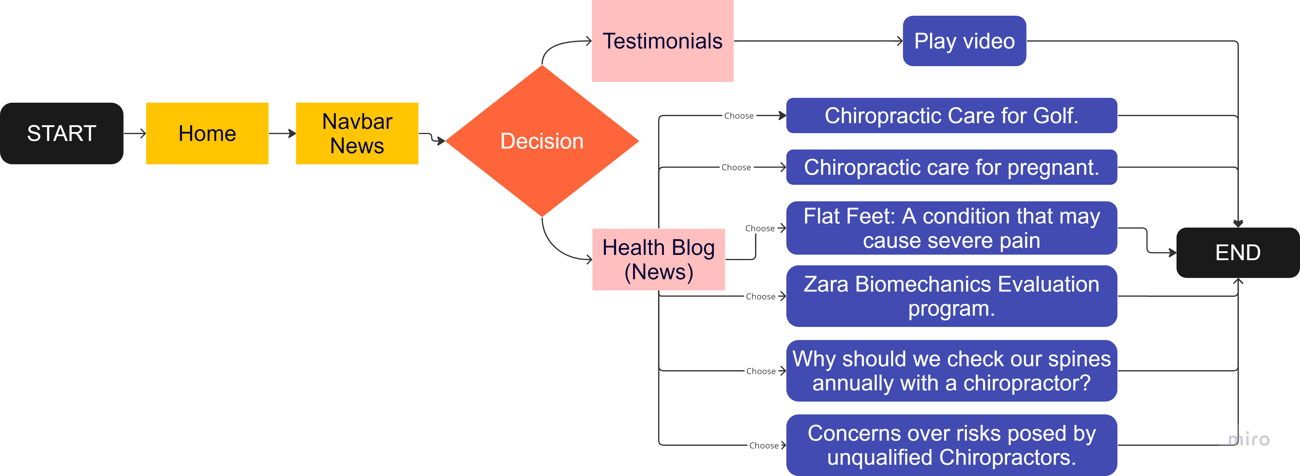

*Booking section usage guidance:*

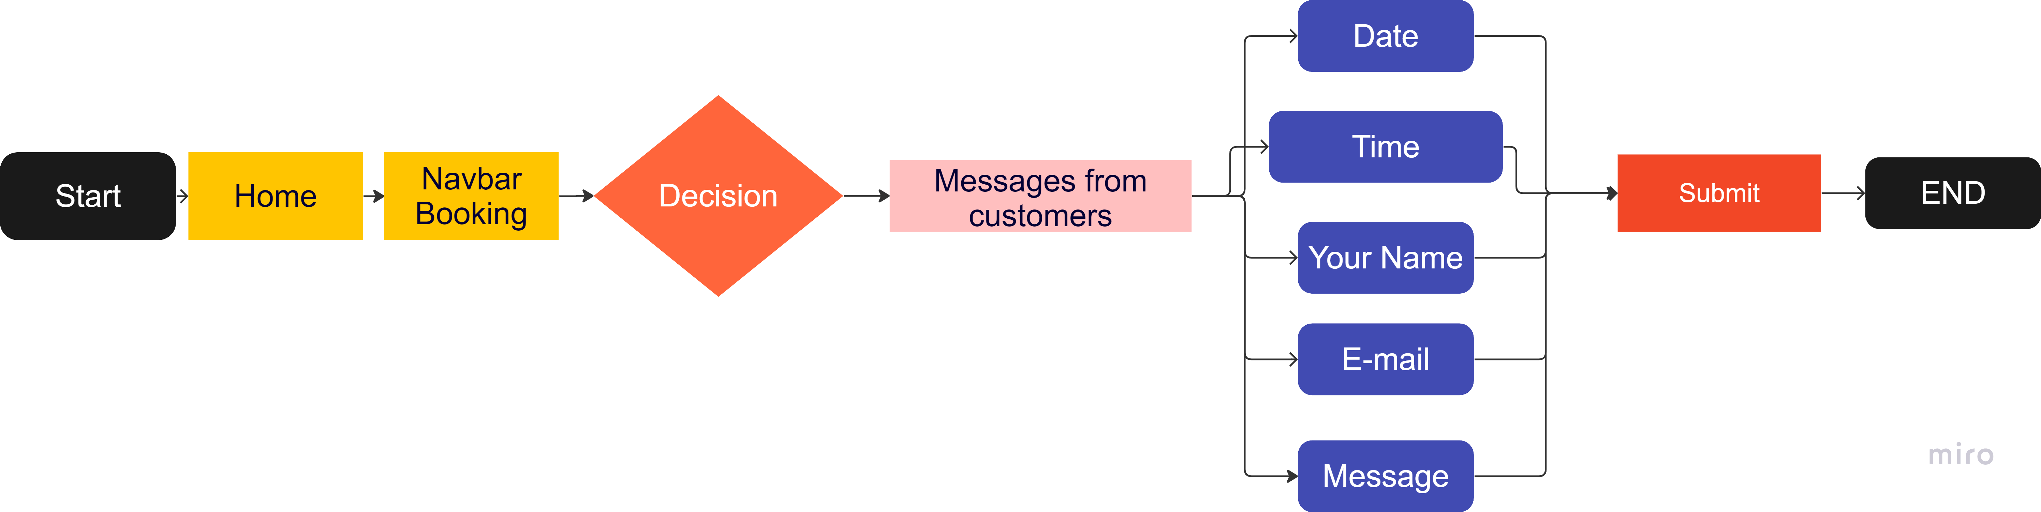

*Contact us page usage guidance:*

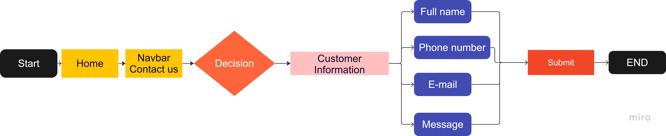  
*Cart and Login/Register usage guidance:*

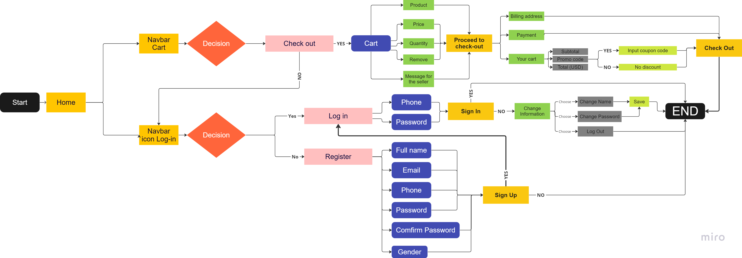

Site Map

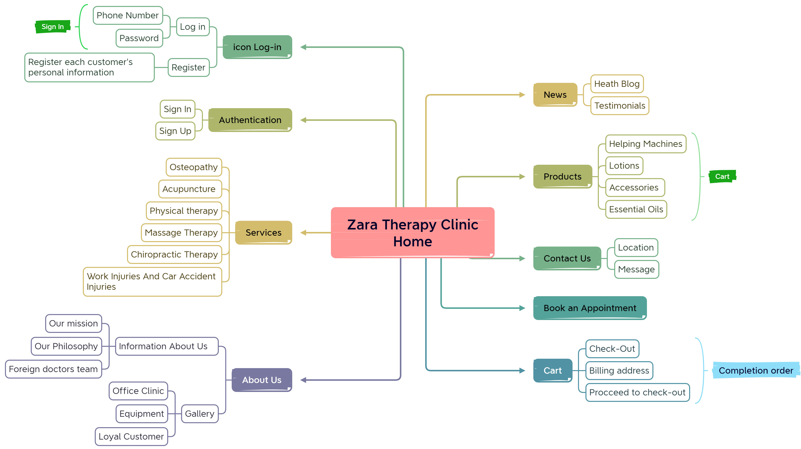

Process Diagrams

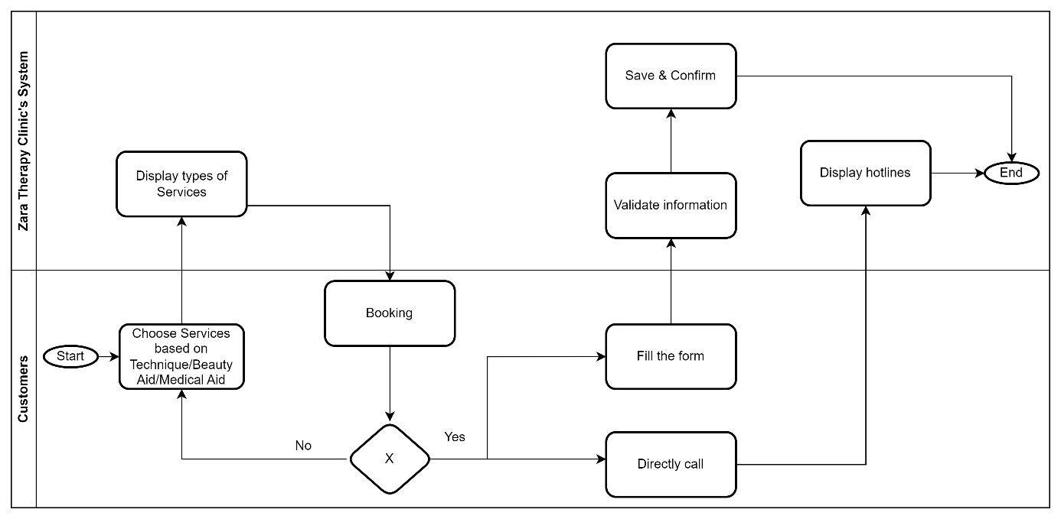

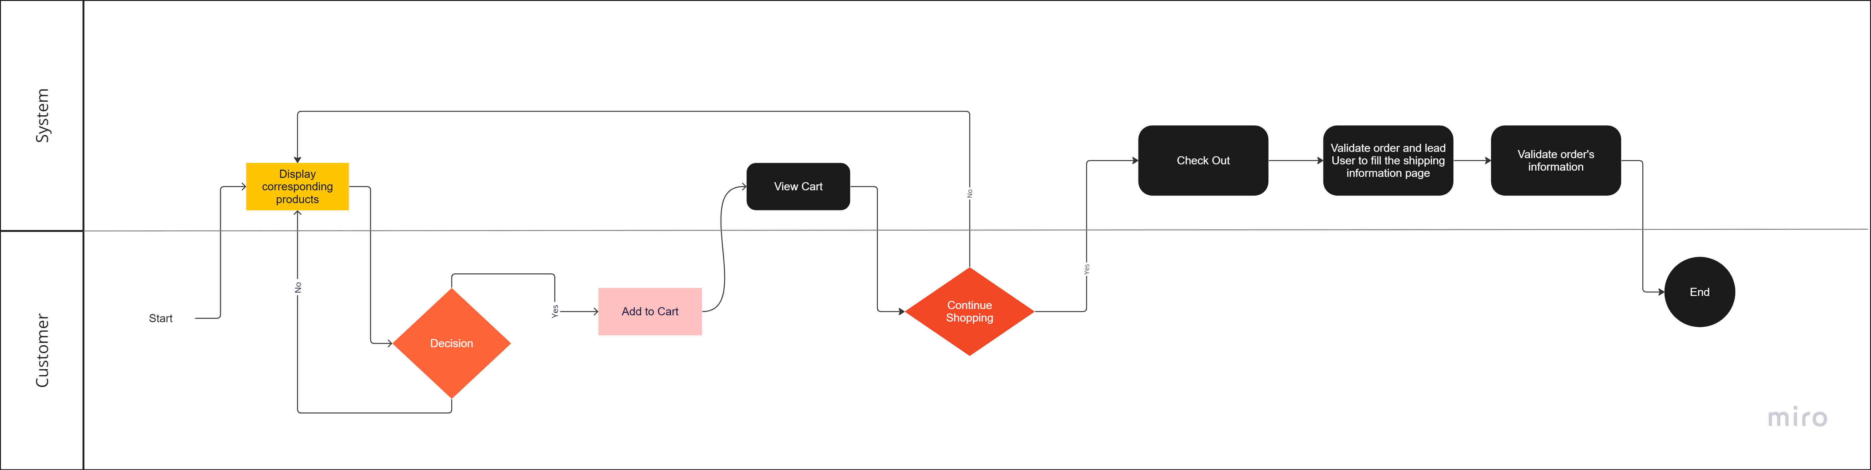

Wire Frame

Wire frame is an important tool in website design and development. Using wire frames helps to understand and outline the interface structure before proceeding to detailed design and programming. It helps define the site structure, focus on user experience, synchronize with related parties and inspections, and test and tweak the design before proceeding with development. With wireframes, the design team has a solid base to ensure consistency, ease of use and appeal for users on the site.

*Homepage Layout*

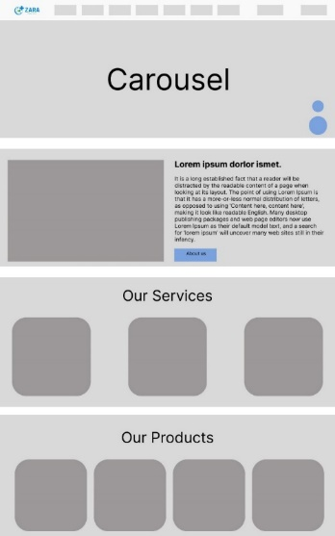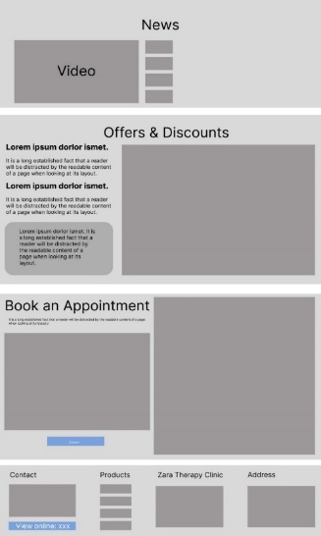

*About Us Layout*

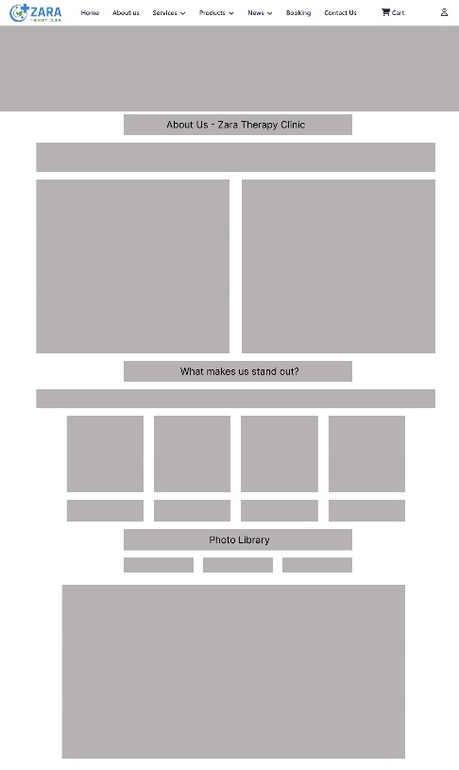

*General Services Layout*



*General Products Layout*

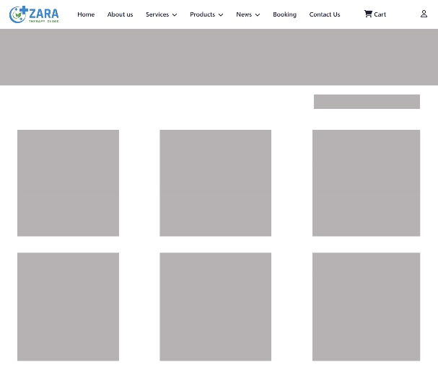

*Health Blog Page Layout*

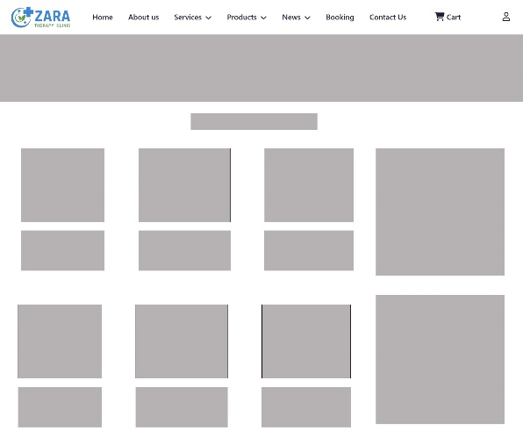

*Testimonials Page Layout*

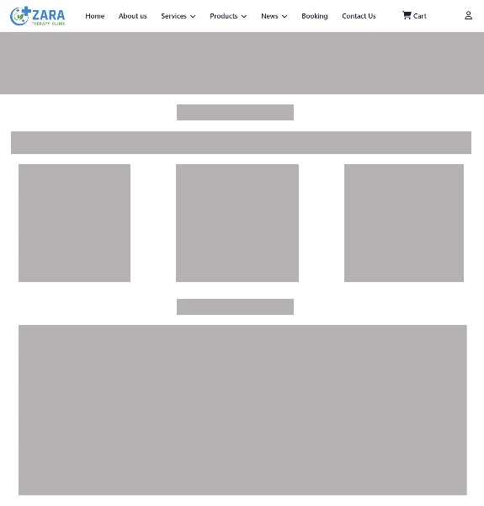

*Contact Us Page Layout*

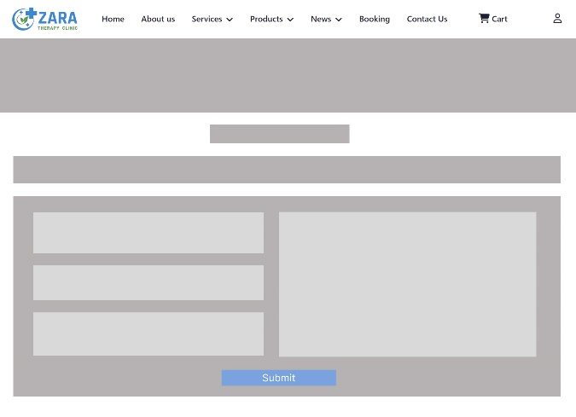

*Check-out Page Layout*

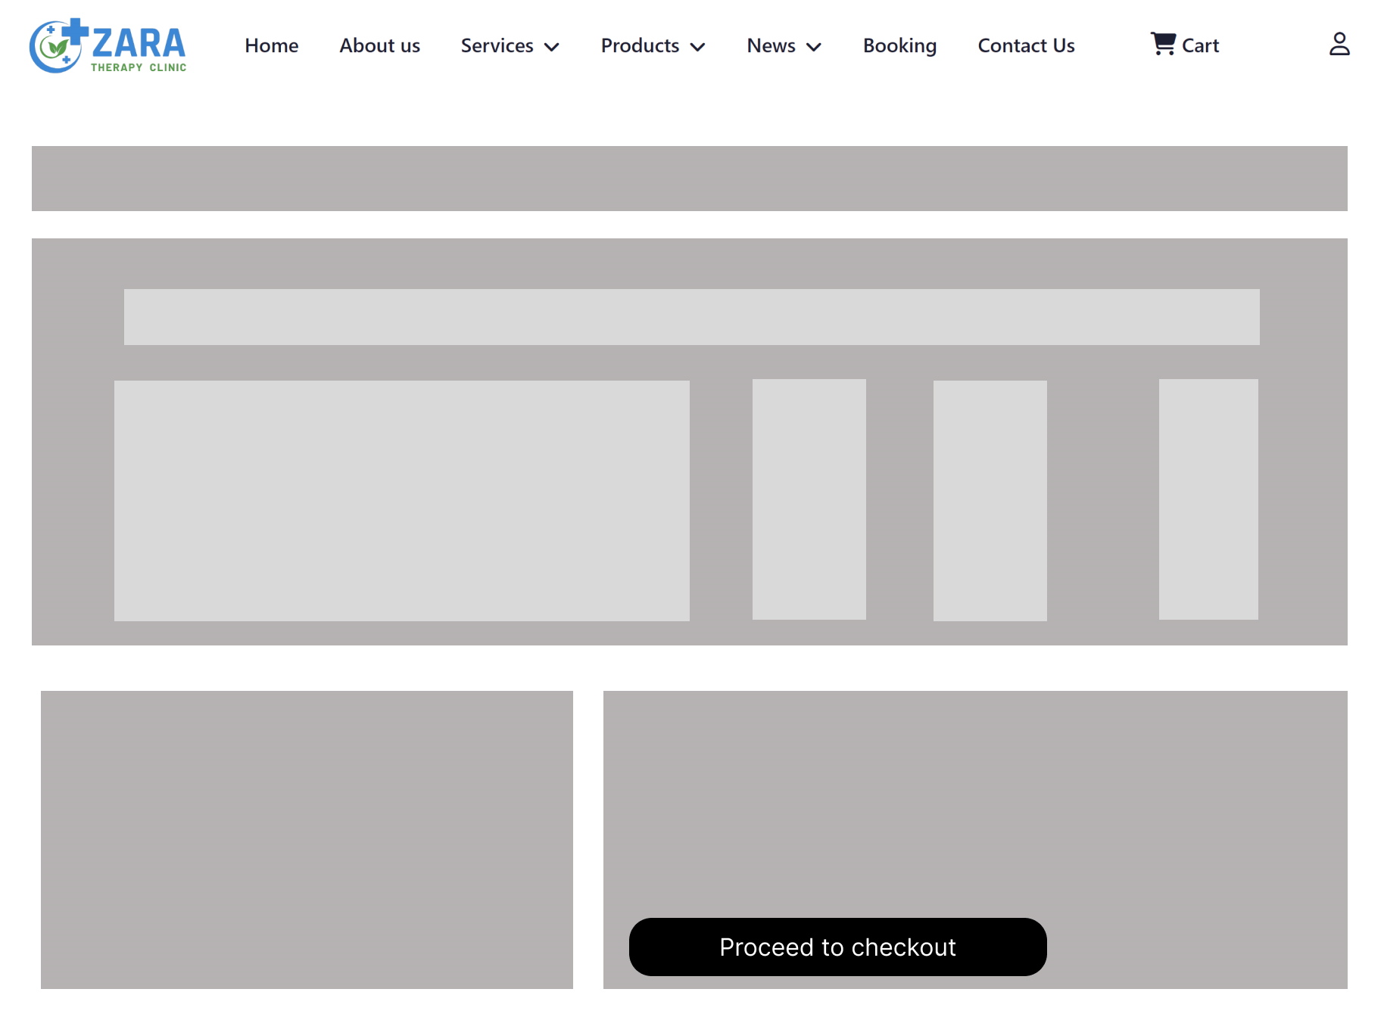

# **User Guide**

**Product name:**

Zara Therapy Clinic website

**Intended use:**

The purpose of using our website is very diverse and brings many benefits to users. By using our website, users have access to a wide range of useful functions and information.

First, the website allows users to book an appointment or contact our clinic directly. The appointment booking process has never been easier and more convenient. Users can select the desired date, time and service with just a few clicks. This saves time and effort for users, no need to call or come in person to book an appointment.

In addition, the website provides a rich source of information about the services and products we offer. Users can easily learn about our treatments, techniques, and methods. Detailed information about each service and product helps users have a clear and complete view of them before deciding to use.

Furthermore, the website also provides educational information that is updated daily. This is where users can learn about health issues, useful tips, and the latest news in the field of healthcare. We place special emphasis on keeping up-to-date information accurate and reliable to ensure that users always receive valuable knowledge and information.

Not just that, our website is also a place where users can get information about news and special discount promotions. We regularly hold promotions, special discounts for our services and products. Through the website, users will not miss any opportunity to save and experience the quality services at preferential prices.

With all the useful functions and information on the website, we are committed to providing the best user experience. Our professional team is always trying to improve the quality of our services and improve the website to meet all the needs and desires of our users. We hope that our website will be a useful and reliable resource for your health and therapy.

**Features:**

We design live chat scenario for real-time interaction with customers. Besides, we provide contact hotlines with hyperlinks letting users easily and directly connect with us. When users scroll down to any other positions within the Home page, a little spinning back-to-top icon appears which will improve the user experience. Moreover, we create a checkout cart for users to easily recheck the previously selected products. There also has an appointment form for user to schedule the booking with our clinic. Additionally, we design a search bar for customers easily search for any kind of products within several Product pages. Especially, we write a script to show quantity of online users to show the popularity of our website. Last but not least, in the Login or Register section, users can conveniently change their password internally and there will also appear username near the login icon after logging in. All of these features are designed to provide the best customer experience, convenience and enhanced interaction between our clients and our clinic.

**Description of the user interface:**

As any other clinics, we design Zara Therapy Clinic’s logo and website with three mainstream colors including white, blue, and green that bring comfort for all users’ eyes while reading or searching on the website. We exclusively design the Home page with the font size of 20 for users with 18 font size in order to let the elders read the page easily and clearly other pages.

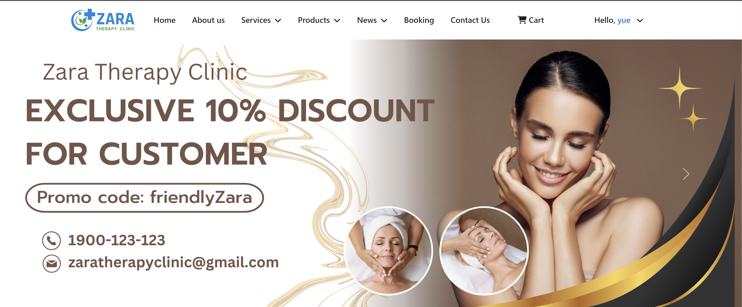

Our website has simple and easy to manipulate for all age users, particularly elders which are our main customers. There is a real-time connection between customers and our employees, they will reply as soon as possible for the customer as well as contact with customers via the phone numbers.

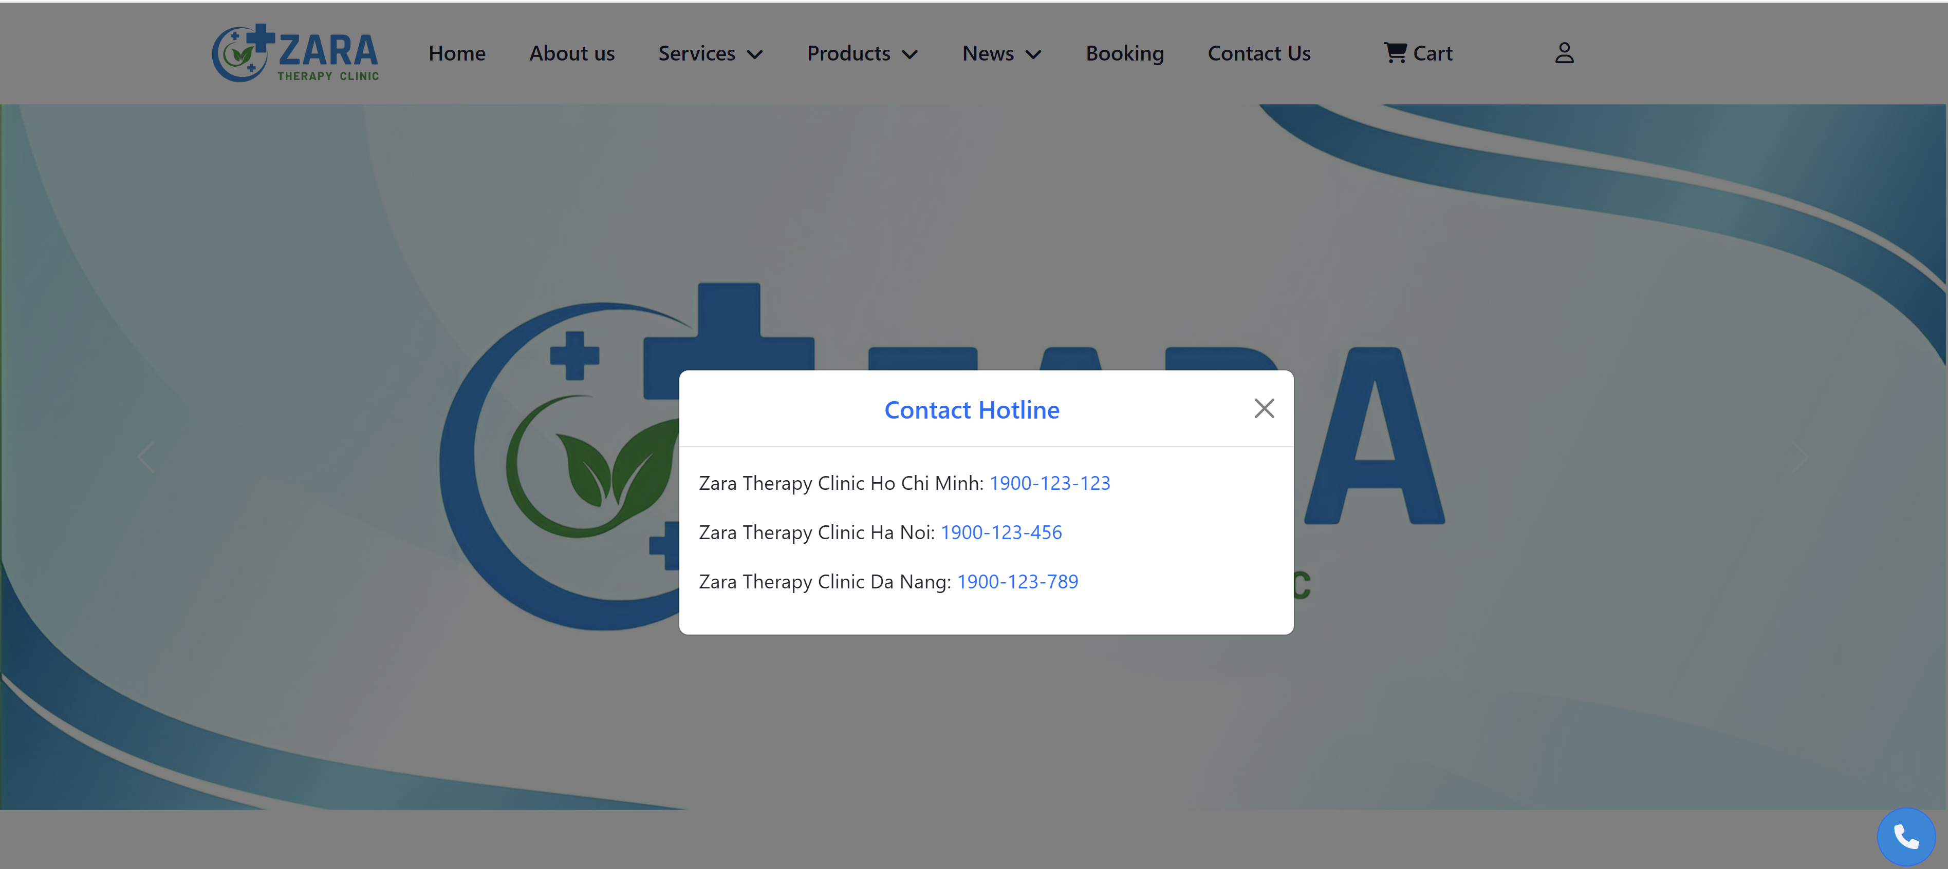

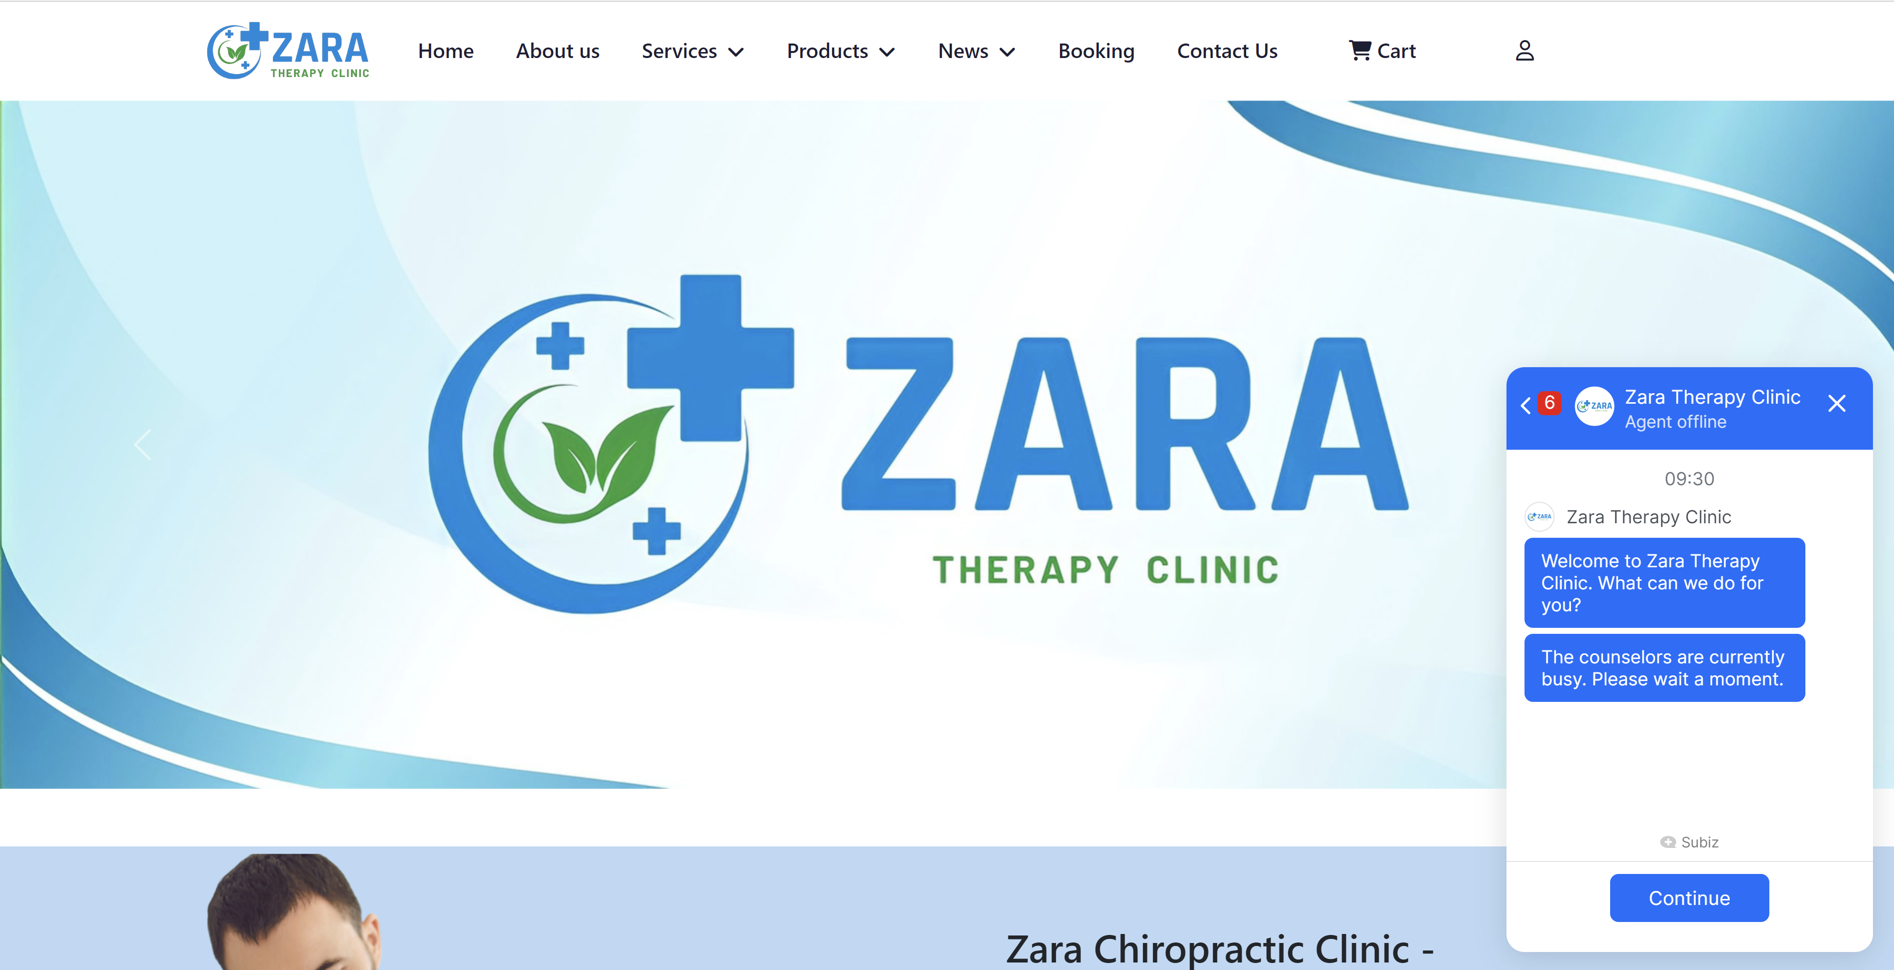

The website also provides some customer testimonials to let other users know more about our therapy clinic.

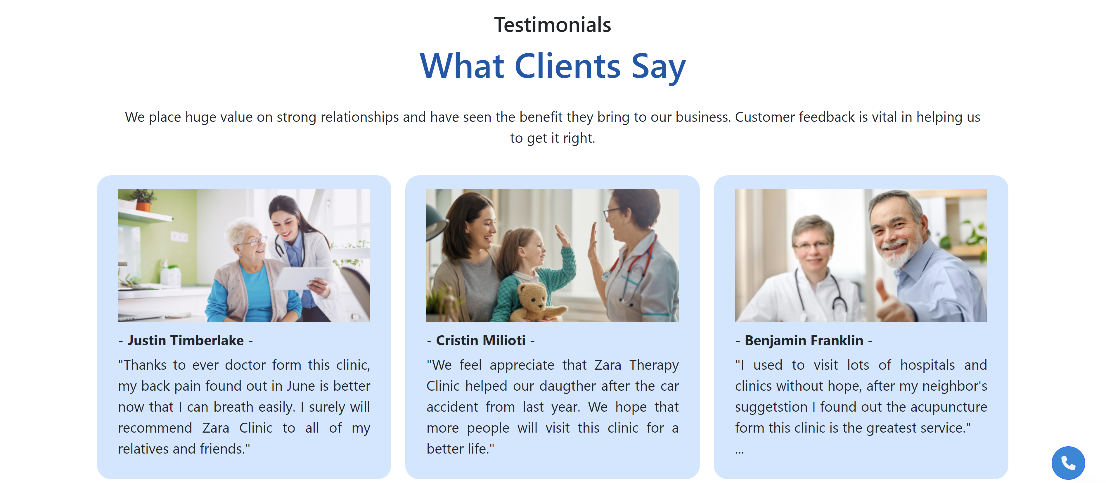

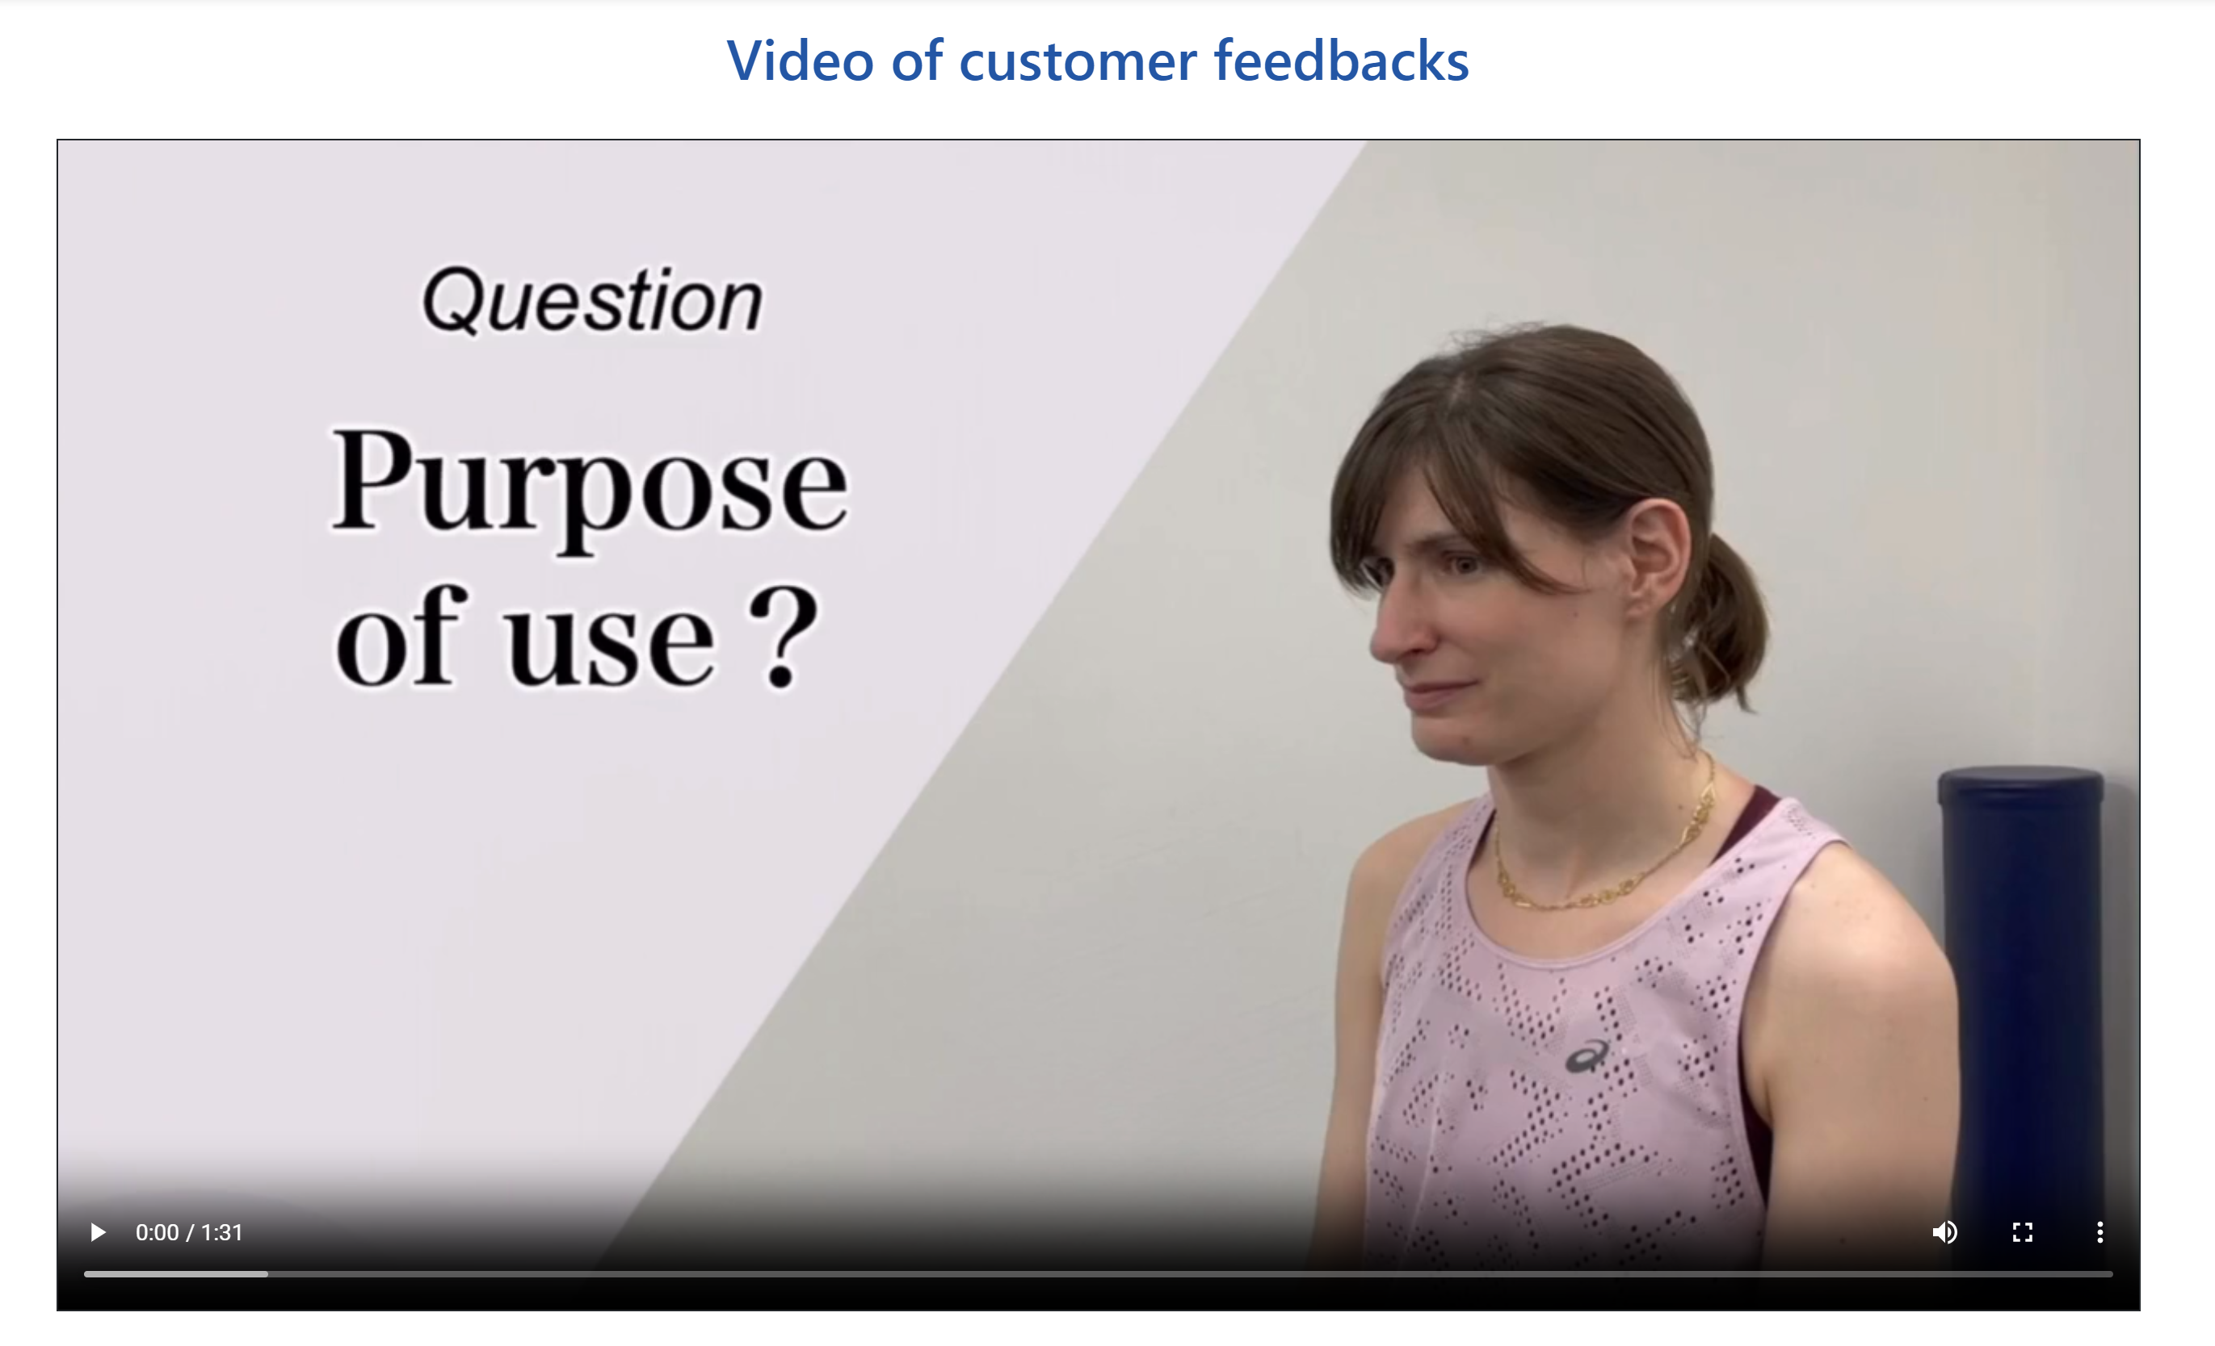

**Description of how to use or operate the product:**

Input:

* + Users can look up information with the search bar.
  + Data of clients reading our clinic’s website.
  + Rating stars and comment on our services or products within the website.
  + Booking any appointments inside our home page.
  + Directly contact us with our branches’ telephone numbers.
  + Customers can adjust the quantity of products on the checkout page whenever they change their minds.

Process:

* Filter the results of what customers are searching for.
* Check and store the data of users reading our website.
* Gather all the rating stars and comment for our products as well as services.
* Accumulate the booking information of our dearest customers.
* When users click any link on our branches’ telephone numbers will directly connect to our online employees.
* Calculate the prices of products based on customers’ changes.

Output:

* Return the result of customers’ searching and display the information on the screen for them.
* Exhibit the data of registered customers.
* Represent customers’ comments and the rating stars of our services and products in the Testimonials site.
* Announcement for the successful booking to let customers know that it was confirmed well.
* Update the product’s final amount depends on customers’ modifications.

**Guidance of using Home page:**



- This navigation bar will promptly lead users to alternative pages which include About us, types of services, list out our several products, Health Blogs, Testimonials and Contact Us pages.

- Booking section is displayed as the landing page with the appointment form

- Shopping Cart will be appeared within Home page when users click into the shopping cart icon. There will appear a small notification with the Checkout button in order to let users easily to order products from Zara Therapy Clinic website.

- Login or Register sections as well will be disclosed whenever customers click the login icon.

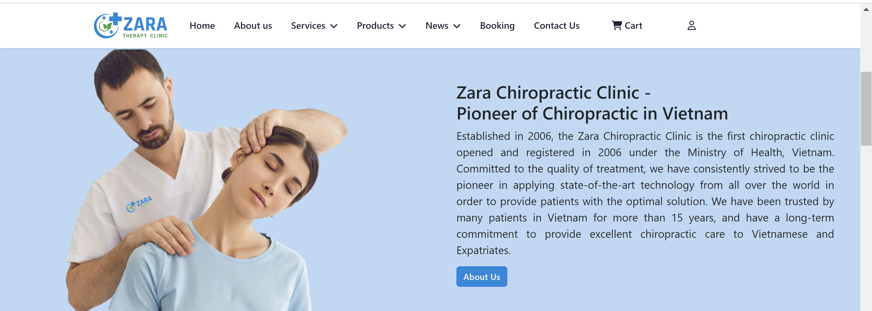

- On any occasion, users click the about us button following in the position, it will bring them to the About us page.

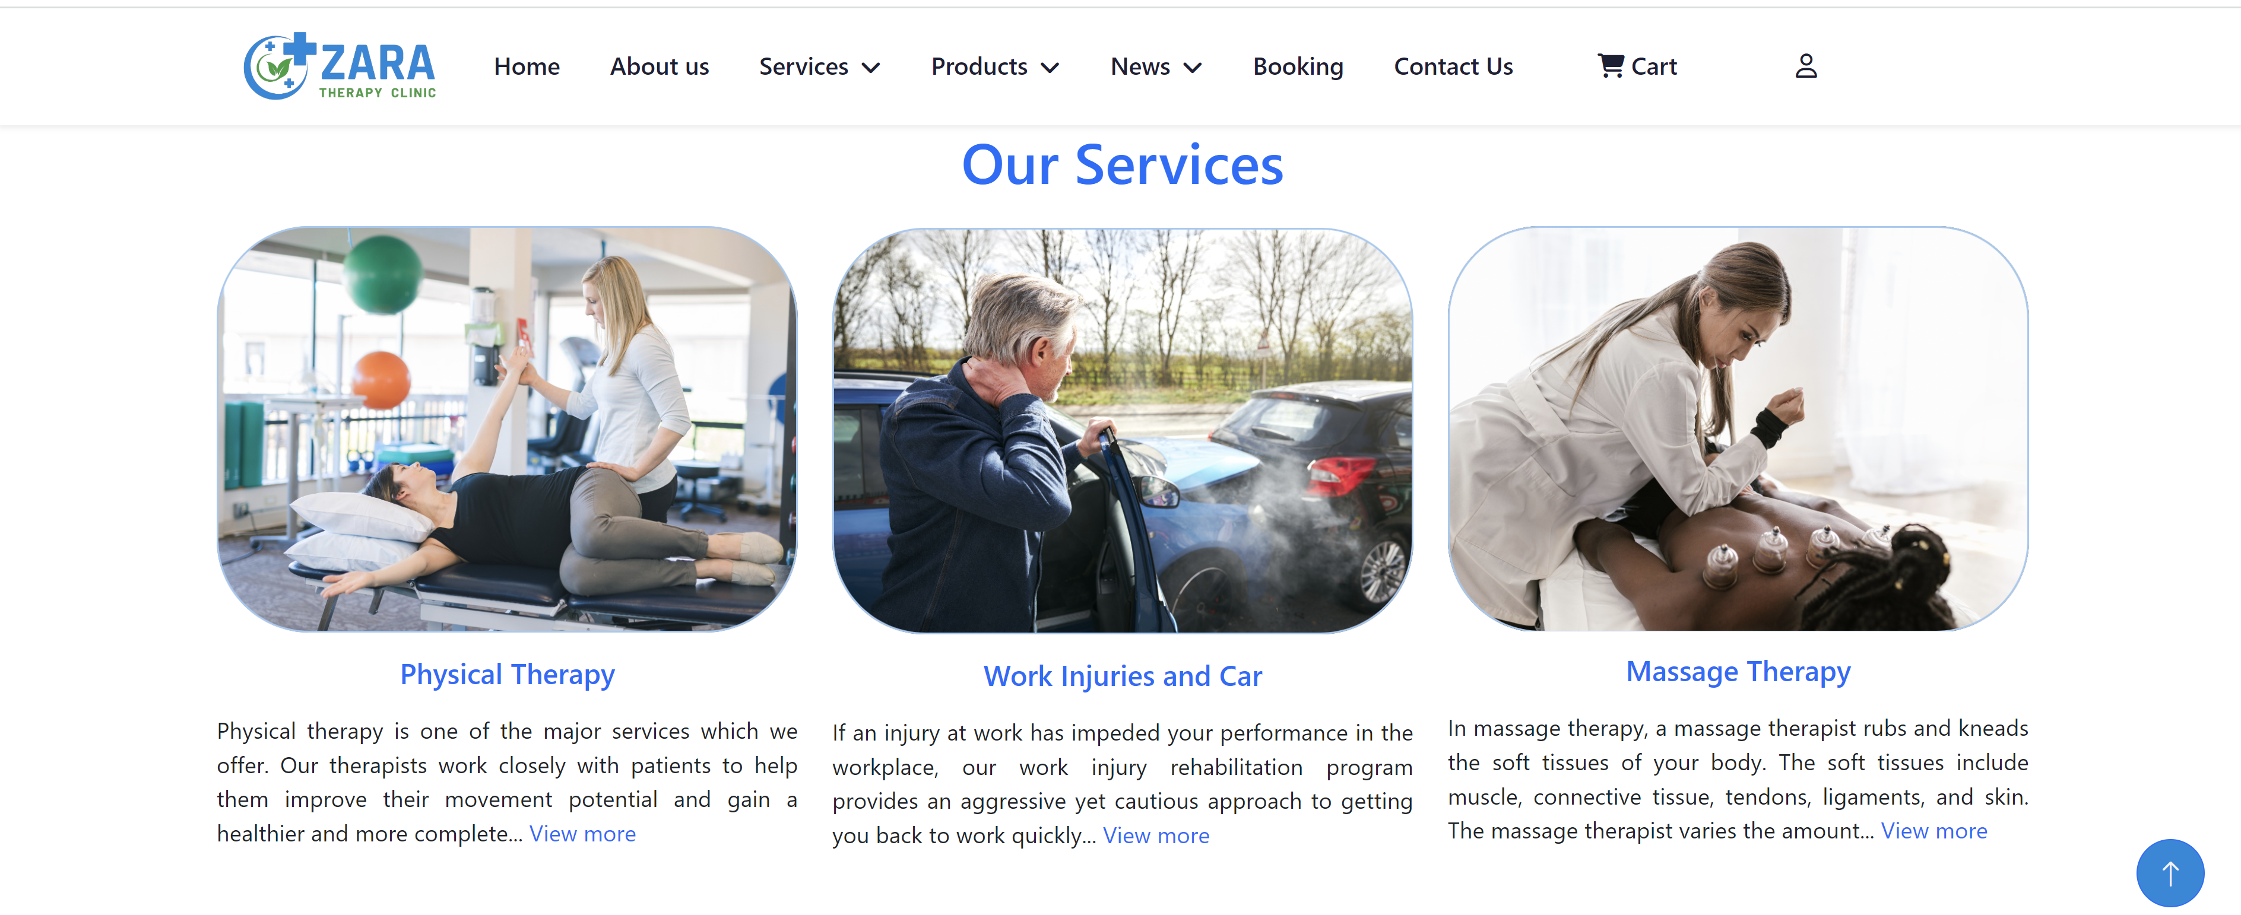

- The View more immediately navigate to small pages of the physiotherapy, massage therapy and the information about work injuries and car accidents.

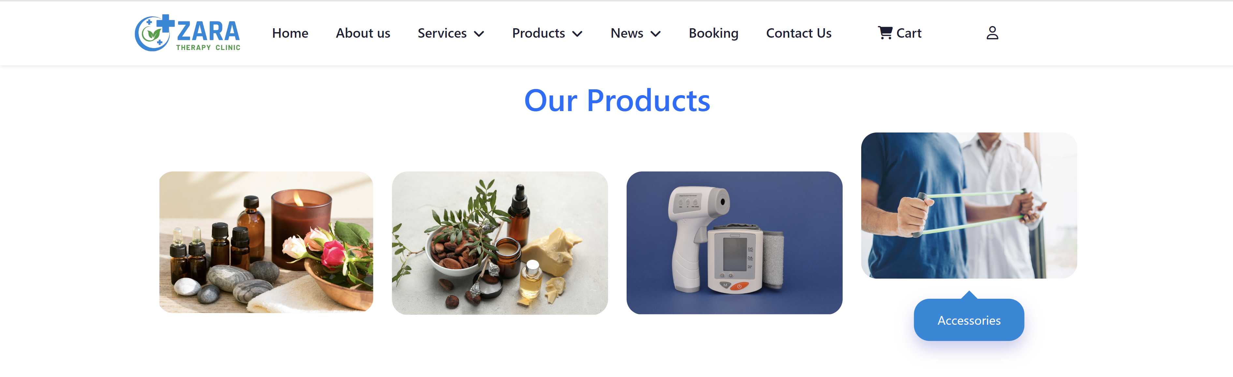

- Hover the mouse into each picture, users will see its name of the product come into sight and clicking on those four little pictures will quickly guide them to the detailed products.

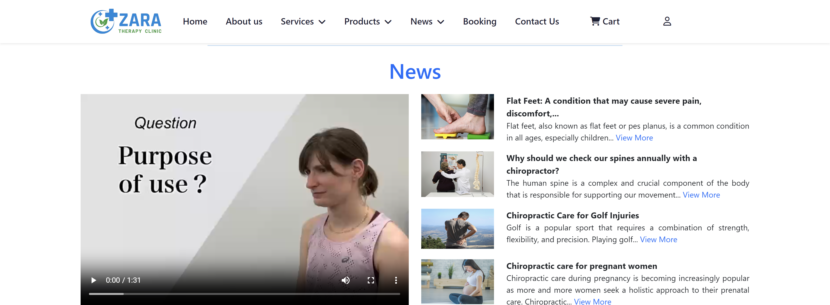

- Users can precisely watch the customer testimonial video when clicking the play button.  
- View more is a function as hyperlink to each article. We designed the News section with four popular issues that Vietnamese people want to treat and heal in order to have better health instead of only focus on eating and exercising.

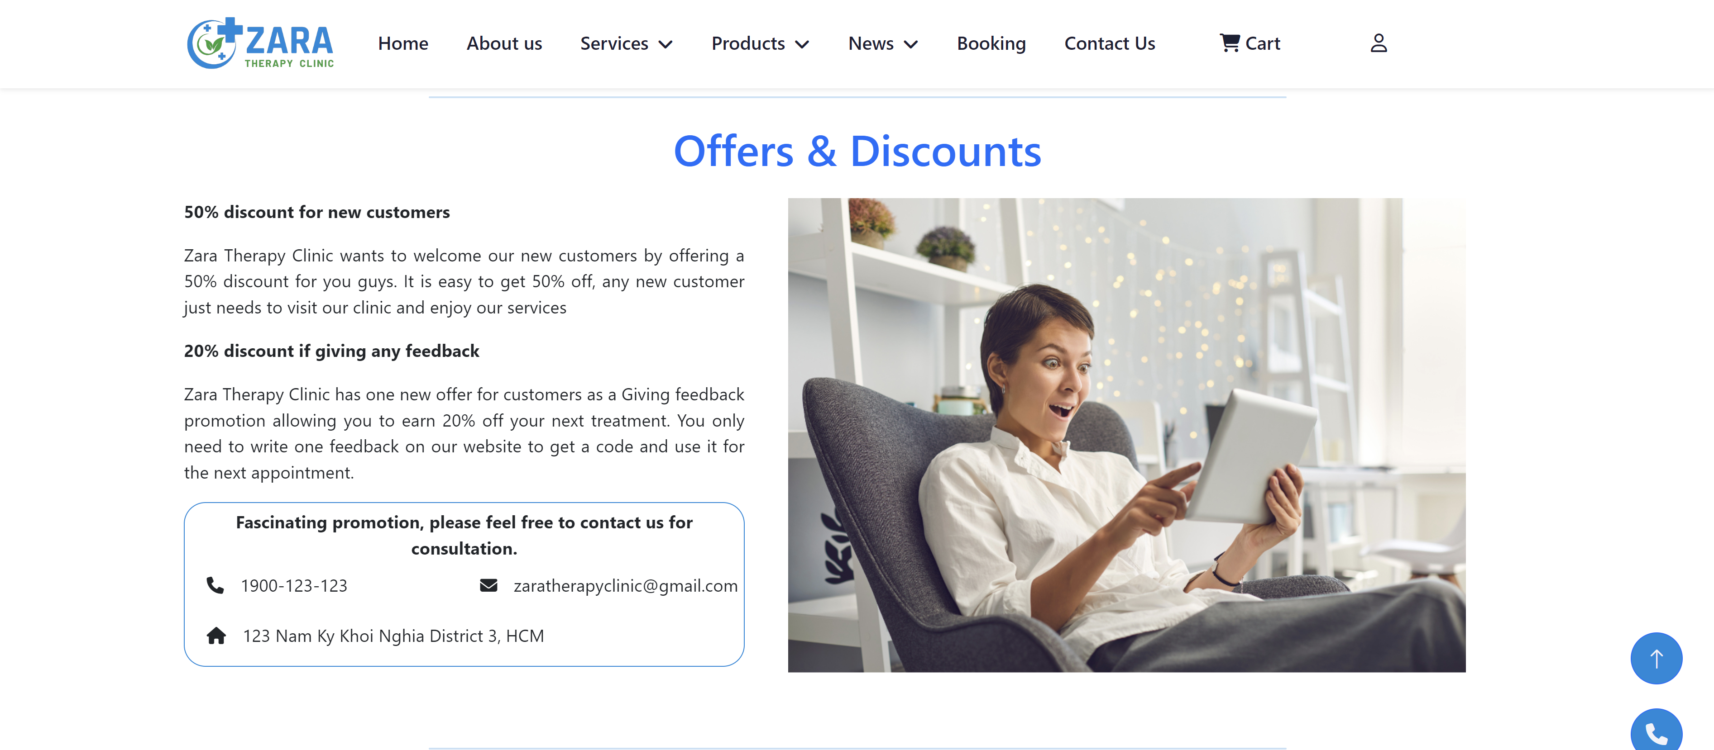

- Zara Therapy Clinic has designed two packages of offers for our customers that are 50% discount for new customers and 20% discount to any customers that give feedbacks to us or in our website. Users can read about our common offers and discounts inside of the Home page or simply contact our employees for more information by using the phone number or email.

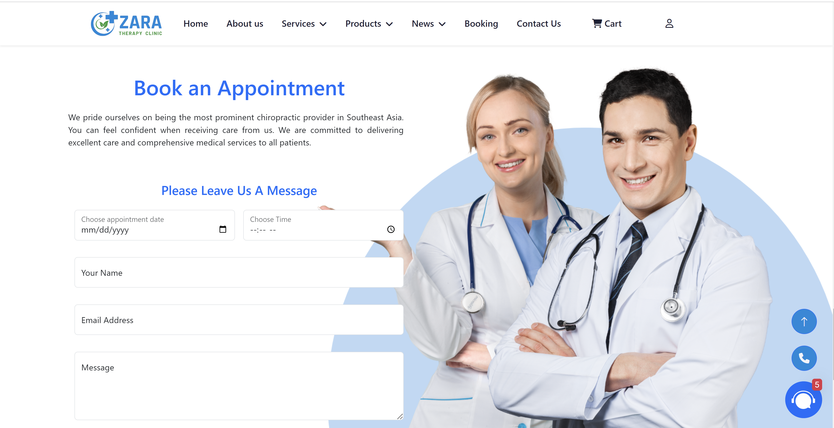

- Our clinic inquires each customer to leave us some basic information in order to note down the booking as well as their pretension while visiting our therapy clinic.

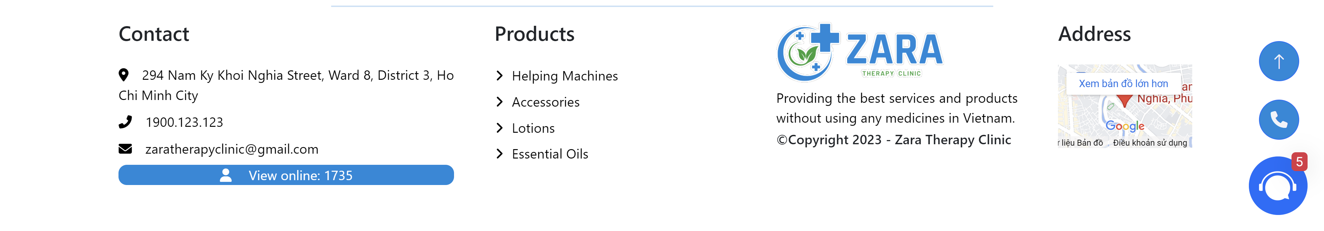

- In the above footer section, we provide adequate information of contacts including address, phone number, and email address. Furthermore, for increasing our profits, we boost the consumption of products by reminding users of our products always in Zara therapy clinic’s website. In particular, the system also displays the user’s current time and detailed latitude and longitude address on our website to ensure convenience and personalized interaction. For user experience side, we have added a “View online” feature so that customers can see how many other users are visiting our website. Some little information about us is shown accompanied by the logo and copyright icon. A mini map is provided to users in order to check the roads to our clinic.

**Guidance of the Booking section:**

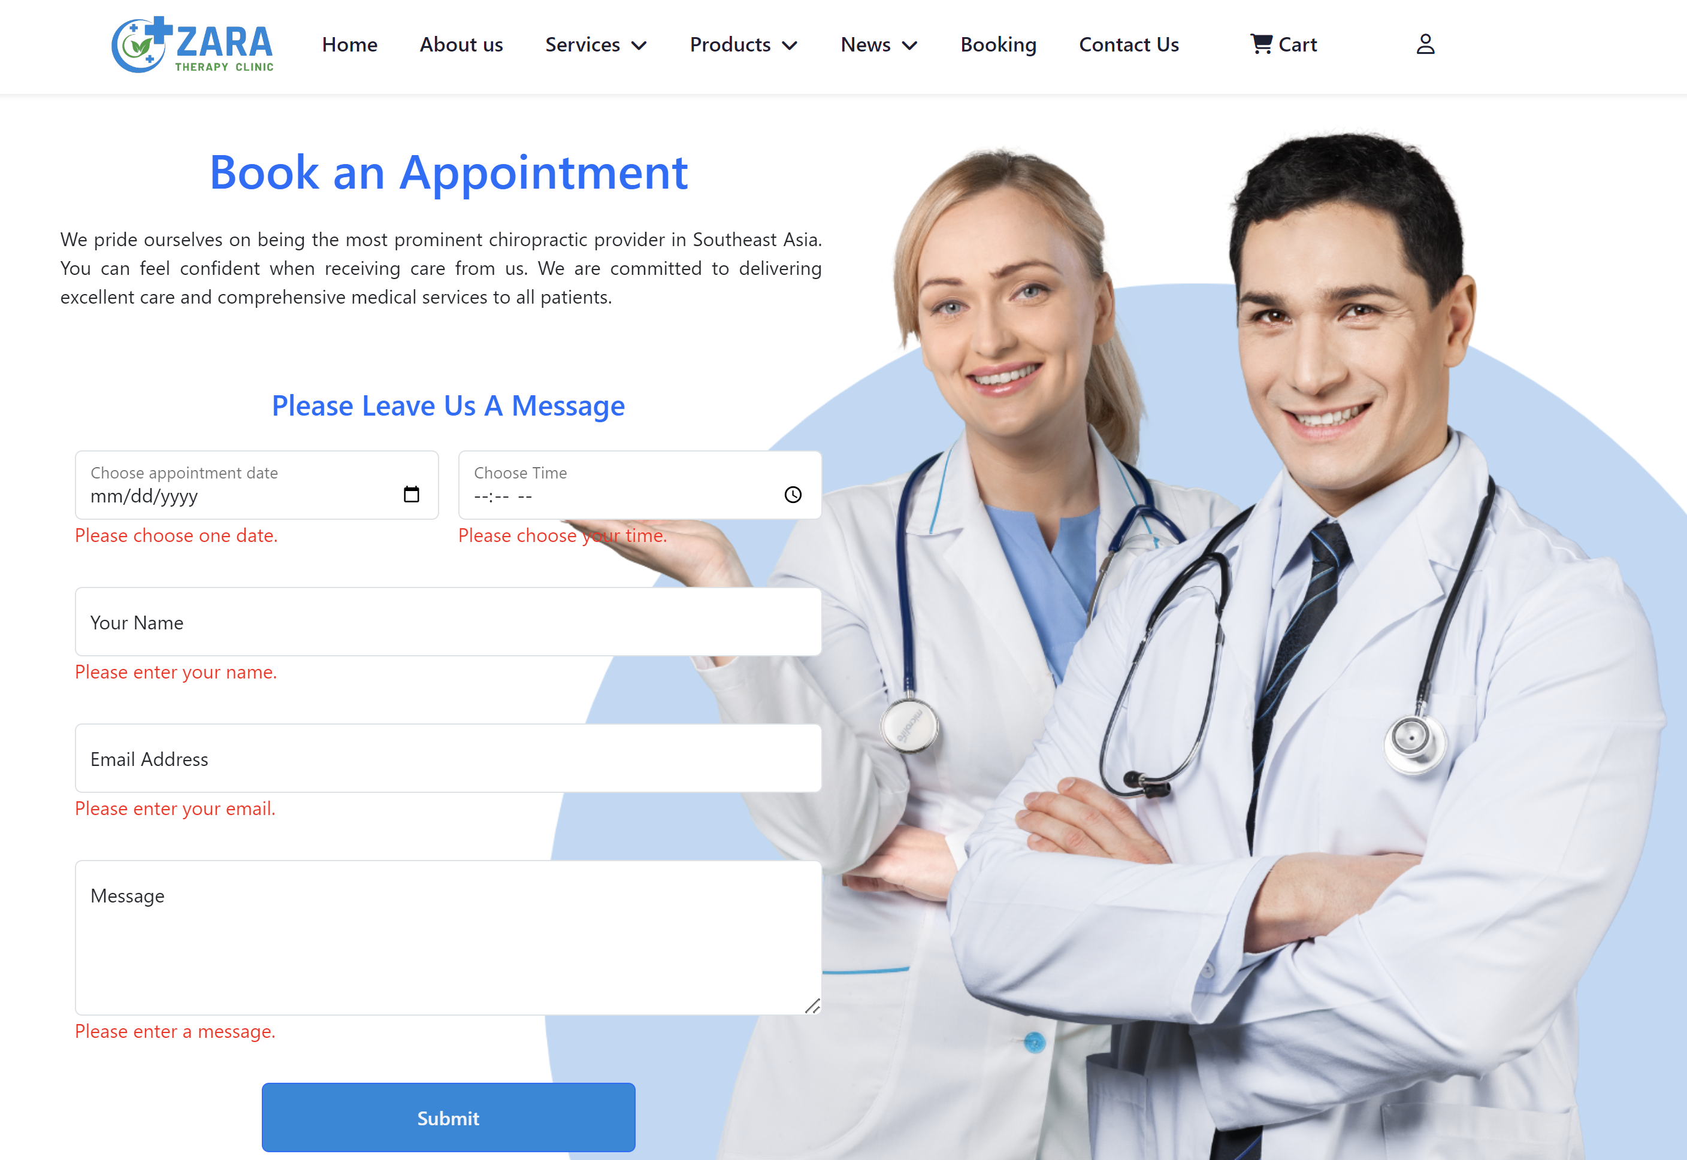

|  |  |  |
| --- | --- | --- |
| Input | Process | Output |
| Users input their available date for appointment | If null, the system will ask users to input  Display the calendar | Display the right date that users chose |
| Users input the appointment time | If null, the system will ask users to input  Display the list of hours and seconds with AM and PM to let user choose the available time | Show the time that users already picked |
| Users input their names | If null, the system will ask users to input | Display users’ names on the screen |
| Emails must be input by users | Display users’ emails on the screen |
| Messages and comments also must be input by users | Display users’ messages on the screen |

**Guidance of the Contact Us section:**

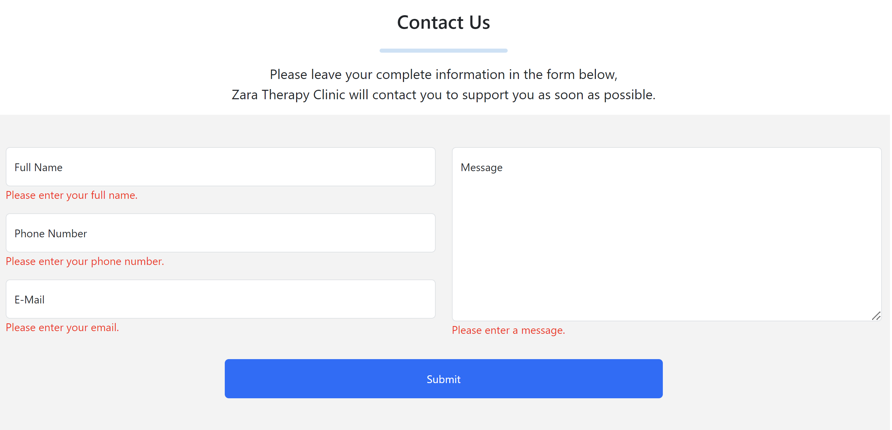

|  |  |  |
| --- | --- | --- |
| Input | Process | Output |
| Users input their full names | If null, the system will ask users to input | Display users’ full name |
| Phone numbers must be input by users as well | Validation form must be 10-digit numbers | Display users’ phone numbers |
| Users input their emails | The validation form must follow abc1@gmail.com | Display users’ emails |
| Messages must be input by users | If there is nothing, the system will ask users to input | Show the messages from users |
| Users click the Submit button | Process and validate information | Popup all the information that users input to let them know that the messages are already sent successfully |

**Guidance of the Login section:**

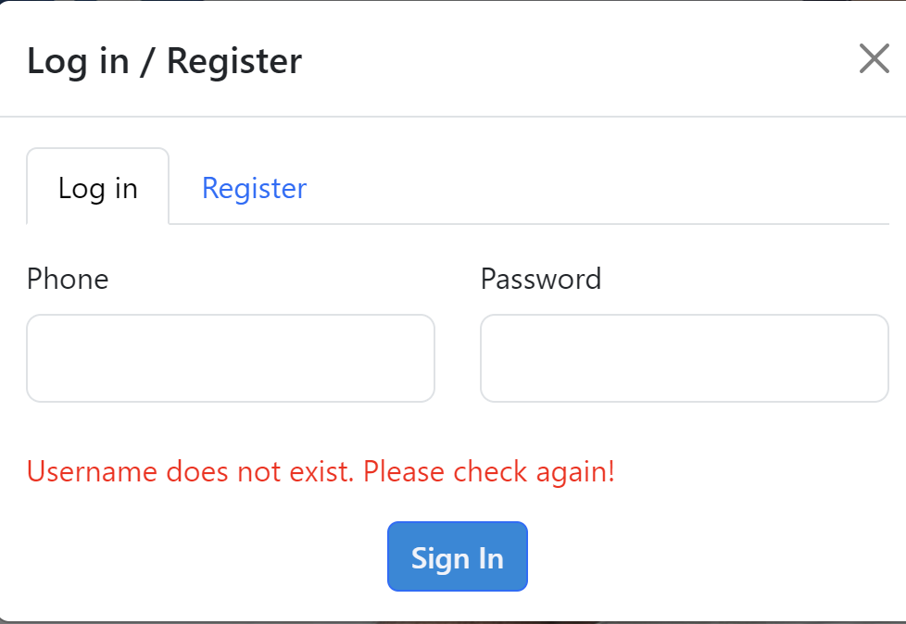

|  |  |  |
| --- | --- | --- |
| Input | Process | Output |
| Users input their phones to login | If null, the system will ask users to input | Display the notification of username does not exist and ask users to input |
| Passwords must be input by users | Display users’ phone numbers |
| Users click the Sign In button | Process and validate information  Look up inside the local storage | Display users’ names on the top right of the navigation bar with the format “Hello, username” |

**Guidance of the Register section:**

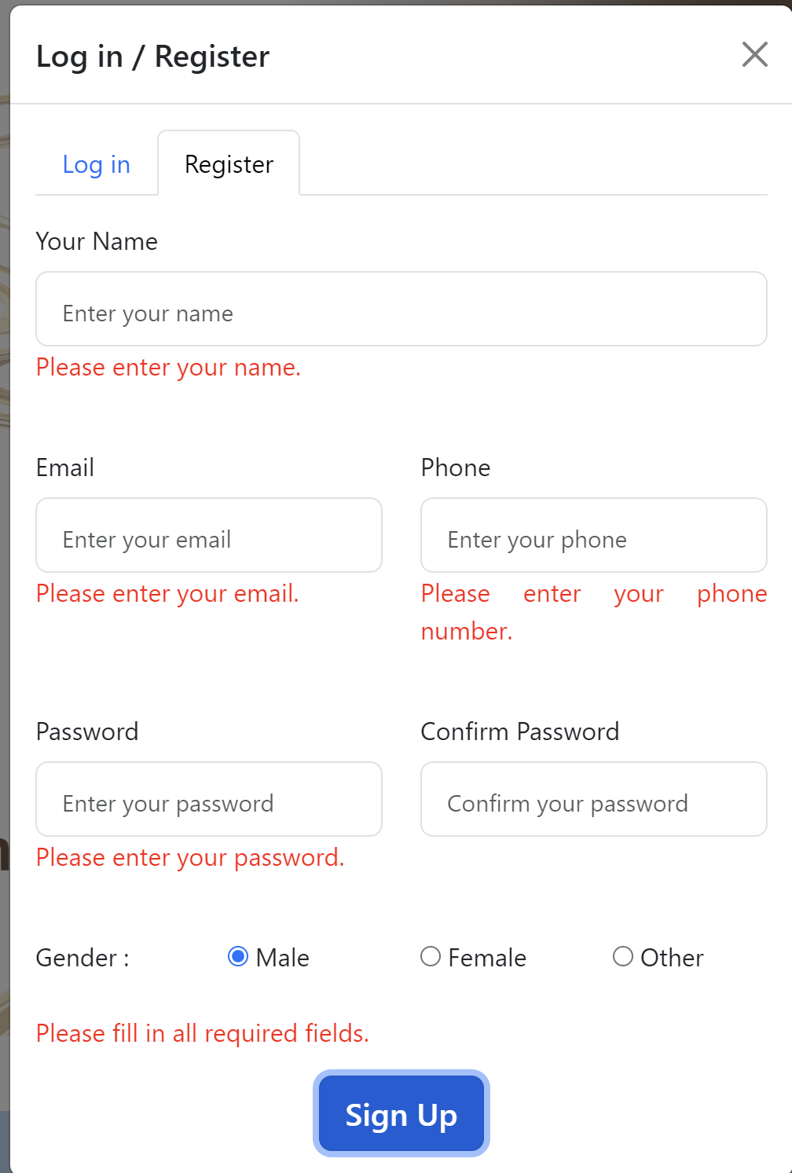

|  |  |  |
| --- | --- | --- |
| Input | Process | Output |
| Users did not input anything | Validation checking | Display the notification of “Please fill all required fields” |
| Users input their name to sign up | If null, the system will ask users to input | Display users’ names |
| Emails must be input by users | The validation form must follow abc1@gmail.com | Display users’ emails on screen |
| Users input their phone numbers | The validation form must be 10-digit numbers | Show up users’ phone numbers |
| Passwords input their name to sign up | - Password must be more than 5 characters  - If null | - Display only number of characters that user inputted but hide the real characters  - Display the notification of “Please enter your password” |
| Confirm password also is needed to be input by the users | Confirm password must be more than 5 characters and must be matched with password |
| Users tick to choose their genders | Must choose one of those three for validation checking | Show users’ genders |
| Click the Sign-Up button | Process and validation checking all the information  Save in the local storage | Display the notification of “Register successfully, please login to continue. You can use "friendlyZara" code to get 10% discount.” |

**Guidance of the Check-out section:**

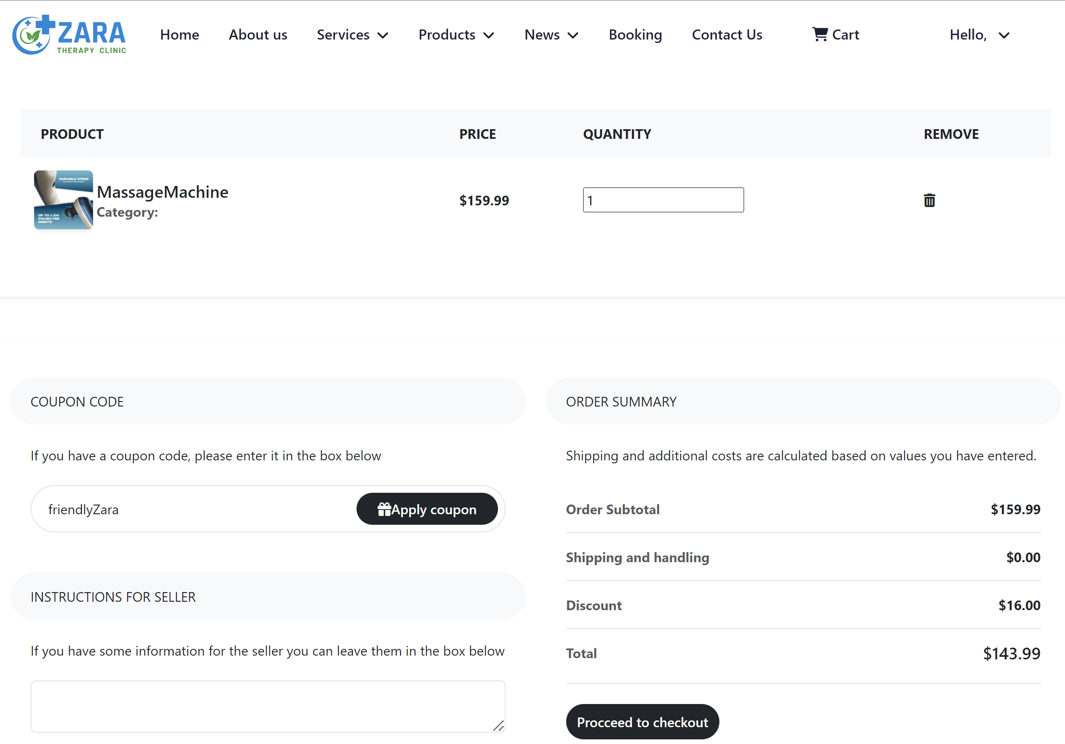

|  |  |  |
| --- | --- | --- |
| Input | Process | output |
| Users can choose more equipment by choosing the quantity | The up and down button will appear when users hover to the quantity box | Show up the quantity of the products |
| Users input the coupon code | - Validate if it is the right coupon  - If not the right coupon code | - The system will count and display the price in the discount part  - The system will pop up the notification of “Your coupon is not valid.” |
| Users input messages for seller also known as our clinic | Save if users input information | Display the messages on screen |
| Users click Proceed to checkout button | Lead users to the Checkout Modal | Popup the Checkout modal |

**Guidance of the Check-out modal section:**

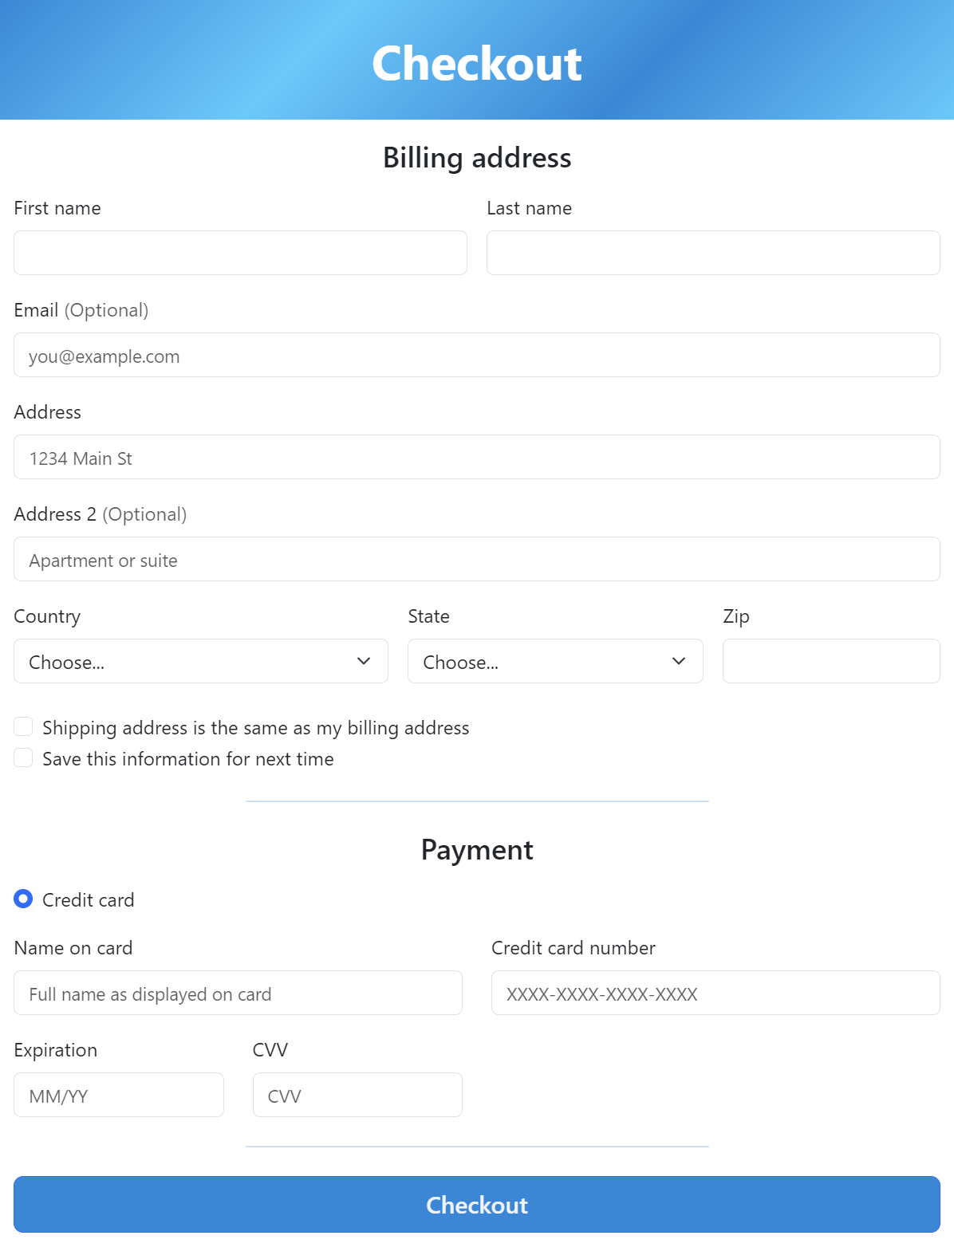

|  |  |  |
| --- | --- | --- |
| Input | Process | Output |
| Users did not input anything but click the Checkout button | Validation checking | Display the notification of “Please fill all required fields” |
| Users input all the fields | The system checks if users input all information | Pop up the notification of “Checkout successfully” |

**Guidance of Search bar in Our Products section:**

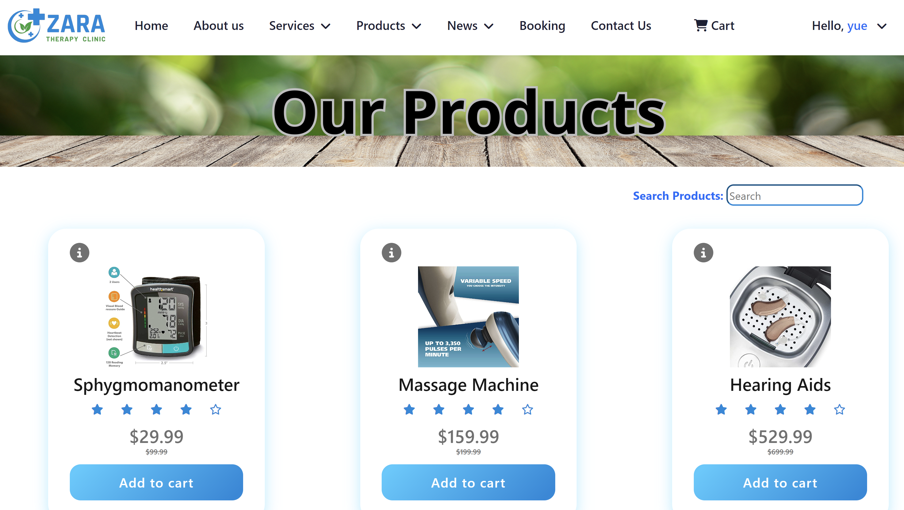

|  |  |  |
| --- | --- | --- |
| Input | Process | Output |
| Users input products’ names in the search bar | Read the data that users inputted and look up in JSON file of products | Display products |

**Guidance of Real-time Chatbot section:**

*Chatbot icon:* 

*The first screenshot:*

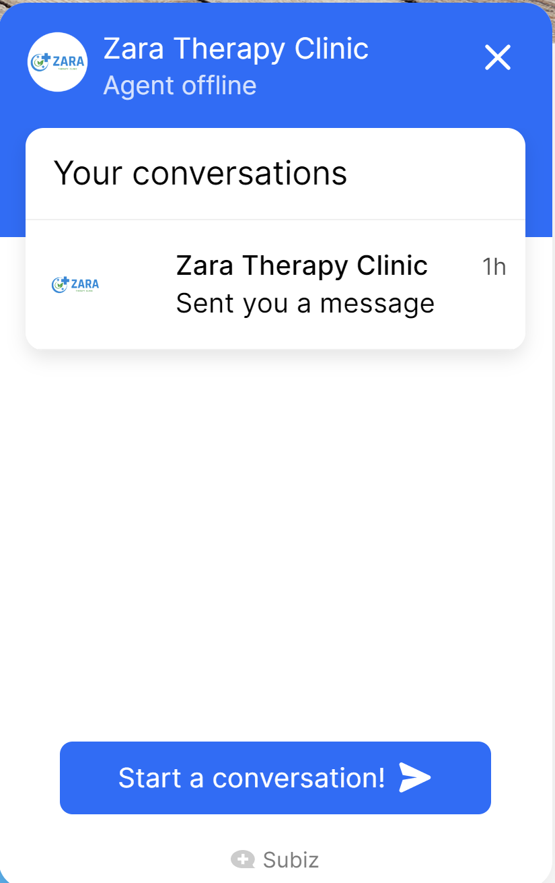

*The second screenshot:*

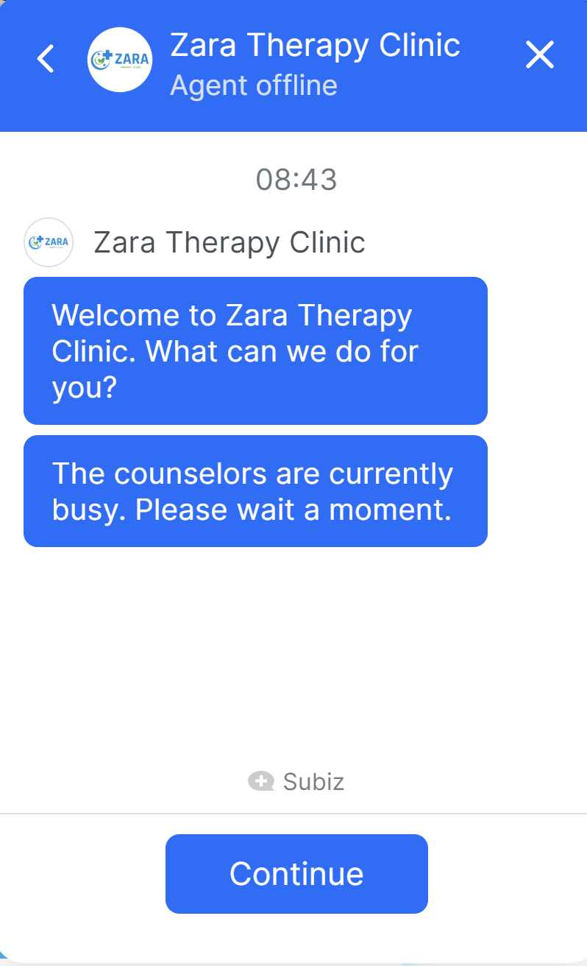

*The third screenshot:*

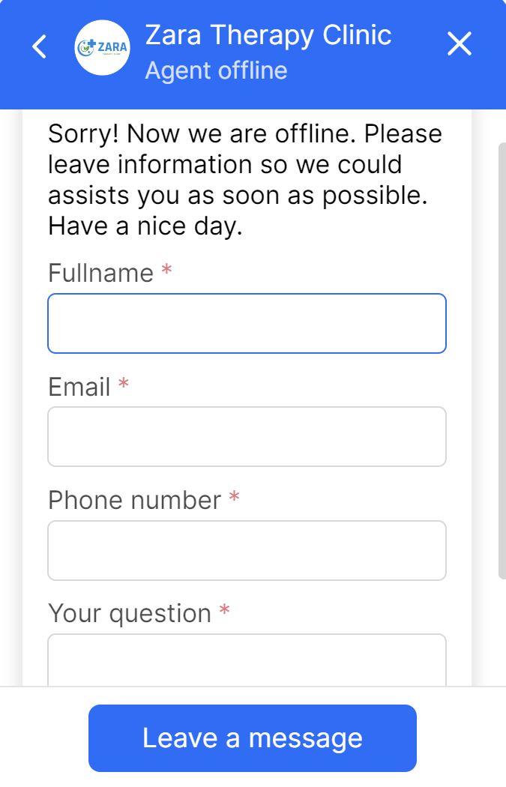

|  |  |  |
| --- | --- | --- |
| Input | Process | Output |
| Users click the chatbot icon | - System sends users’ inquiries to Subiz API  - If anyone from our team is online  - If nobody is online | - Display the conversation box as in the first screenshot  - Reply and users  - Auto show up the message that we added in the system |
| Users click into the conversation | Navigate inside the conversation | Display the message that we saved inside the system |
| Users click the Continue button | Process to the input form | Display the form on screen |
| Users input their name to sign up | - If null, the system will ask users to input  - System will read what users inputted | - Notification of “The value must not be empty” will be shown  - Display users’ names |
| Emails must be input by users | - If null, the system will ask users to input  - The validation form must follow abc1@gmail.com | - Notification of “Email is not valid” will be shown  - Display users’ emails on screen |
| Users input their phone numbers | - If null, the system will ask users to input  - The validation form must be 10-digit numbers | - Notification of “Phone is not valid” will be shown  - Show up users’ phone numbers |
| Questions must be inputted by the users | - If null, the system will ask users to input  - System will save the questions | - Notification of “The value must not be empty” will be shown  - Display users’ questions on screen |
| Users click into the Leave message button | System will check the validation | Display the conversation box |

**Guidance of Call icon section:**

*Call icon: *

*The first screenshot:*

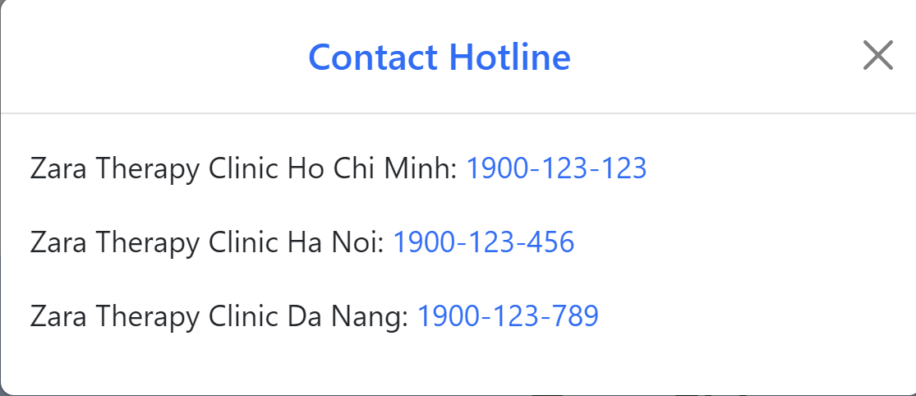

*The second screenshot:*

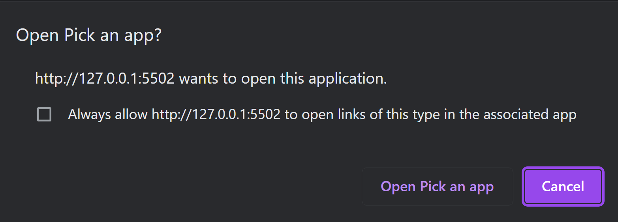

|  |  |  |
| --- | --- | --- |
| Input | Process | Output |
| Users click the Call icon | System will read the inquiries from users | Display the hotlines as shown in the first screenshot above |
| Users click one of those three hotlines | System will accept the requests | Pop up the notification as shown in the second screenshot |
| Users tick into the small box of “always allow…” | System will read the request | Users will tick into the small box and open Pick an app to call our clinic automatically |
| Users click into Cancel button | System will accept the requests | Cancel the calling request |

# **Module Descriptions**

|  |  |  |
| --- | --- | --- |
| Input | Process | Output |
| Homepage | | |
| Carousel | Display six images to show a glance of our clinic | For user read only |
| About us | Present the initial thumbnail of About Us page  Function as a hyperlink to the About Us page | Navigate user to About Us page |
| Our Services | Exhibit our types of services per Technique/Beauty Aid/ Medical Aid  The View more has a function as a hyperlink to the detailed pages of three services included massage therapy, physiotherapy and work injuries and car accidents | Guide user to those three pages |
| Our Products | Demonstrate kinds of products selling  Functional link to the outline page of our products | Bring user to outline page of our products |
| News | Illustrate the customer testimonial video and some titles of health blog’s contents  The View more button direct to News page | Navigate user to News page |
| Offers & Discounts | Display two common discounts for customers | For user view only |
| Book an Appointment | User can input their information and submit to our system | Validate and save the booking |
| Footer | Exhibit our contact, kinds of products, copyright, and mini map | Non-editable on users’ side |
| About us | | |
| About Us information | Display Our Mission, Our Philosophy, introduction about our Doctors, and prominent of Zara Therapy Clinic | For user read only |
| Photo library | Illustrate our clinic’s office images, pictures of patients and doctors, and our equipment’s pictures |
| Services – Chiropractic page | | |
| Chiropractic definition | Provide information for users | For user view only |
| Advantages of having Chiropractic |
| Services – Osteopathy page | | |
| Definition of Osteopathy | Implement more information about this type of service for users | Non-editable on users’ side |
| Osteopathy treatments |
| Benefits of Osteopathy |
| Services – Physical Therapy page | | |
| Physiotherapy definition | Display information about this treatment | Read-only for all users |
| Goals of its treatment |
| Betterment after employing Physiology |
| Services – Work Injuries And Car Accident Injuries page | | |
| Rule of accident afterward | Provide useful tips for users after mishap | For user view only |
| To-do list after the accidents |
| Advantages of having therapies after accident |
| Services – Acupuncture page | | |
| Facts about Acupuncture | Explain about this treatment | Non-editable on users’ side |
| Common conditions of its treatment |
| Services – Massage Therapy page | | |
| Overview | Clearer information about this treatment will be shown for users | View-only for users |
| Massage benefits |
| Helpful for HIV/AIDS |
| Video of massage therapy |
| Products pages | | |
| Helping Machines | A glimpse of products’ images, feedback, stars prices and its after deduction | Navigate customers into small pages of each product |
| Accessories |
| Lotions |
| Essential Oils |
| Health Blog | | |
| News | Articles of educational information | Bring users to small pages of each article |
| Testimonials | | |
| Customers’ opinions about our clinic | Show images of customers and doctors with the feedbacks | Read-only for users |
| Video of customer testimonials | Demonstrate customer thought about our service | Non-editable on users’ side |
| Contact Us | | |
| Registry form | Showing the register form for users | After validation, notification will appear for users |

# **Conclusion**

In this report, we already examined and evaluated Zara Therapy Clinic’s website, a professional and specialized in therapy, healing, and health caring. Based on the key contents that we discussed and referred to within this report, we realized that this website has brought many benefits and values to customers.

One notable advantage of the website is its attractive and user-friendly interface. With a dominant blue-white color scheme, the website creates a friendly and comfortable feeling for the users. The interface has been designed to be user-friendly and suitable for all ages, ensuring that customers can easily find information and use the website's functions conveniently.

Another strong point of the website is the provision of discount codes for registered customers purchasing at the clinic. This not only motivates customers to use the services of Zara Therapy Clinic but also demonstrates the clinic's commitment to providing benefits and value to customers. Because of the discount codes, customers can save a portion of the cost when using therapy services and purchasing health support products.

The website also provides comprehensive information about therapy for patients. The services provided include Chiropractic Therapy, Osteopathy, Physical Therapy, Work Injuries and Car Accident Injuries, Acupuncture, and Massage Therapy. By providing detailed information about these services, Zara Therapy Clinic ensures transparency and openness in the treatment process. The world-class professional and renowned medical team, combined with the most advanced technology from the United States and Japan, creates the best conditions for customers to receive professional and effective care and treatment.

Zara Therapy Clinic's website focuses not only on providing therapy services but also provides detailed information about products and instructions for using the products, especially for therapy and post-treatment health recovery. This demonstrates that the website serves not only as an information channel but also as a valuable resource for customers to grasp and apply healthcare methods in their daily lives.

Another important factor is the contribution of top doctors in sharing knowledge and experience about health through health articles on the website. These articles not only provide information about health signs but also help customers understand the treatment process and healthcare methods better. This helps customers gain more confidence in choosing and implementing appropriate healthcare measures.

Another commendable feature of the website is the ability to make online appointments. Customers can easily schedule appointments online through the website to receive enthusiastic advice from support staff. This saves time and effort for customers and creates convenience in arranging the clinic's schedule.

The website also provides multiple ways for customers to contact and consult, including telephone numbers and online chat boxes. By providing these contact channels, Zara Therapy Clinic affirms its commitment to responding to and supporting customers quickly and effectively. Offering multiple contact options helps customers easily choose the appropriate method and find convenient support and advice.

Zara Therapy Clinic not only creates an attractive and professional website but also pays attention to the customer's shopping experience through a convenient shopping cart. Customers can add the products they want to purchase to the shopping cart and proceed with easy and convenient payment. After completing the order, Zara Therapy Clinic commits to delivering the products quickly and with no shipping fees. This demonstrates care and special attention to customer satisfaction and the desire to maximize their health benefits.

Finally, Zara Therapy Clinic encourages customers to create personal account information for easy tracking of progress and quick purchases. Each customer receives a 10% discount code for each monthly order, an attractive advertising campaign for new customers. Creating an account not only helps customers manage and easily access services and products but also provides significant benefits and advantages to them.

In summary, the website of Zara Therapy Clinic has fulfilled all the important elements to provide convenience, information, and professional care to customers. The eye-catching and user-friendly interface, optimized operations, discount codes, detailed information about services and products, transparency and openness in the treatment process, along with convenient appointment scheduling and contact features, a convenient shopping cart, and attractive promotional programs, all contribute to a high-quality and trustworthy website for customers.

Zara Therapy Clinic focuses not only on providing therapy services but also prioritizes the customer's care and health. The combination of professionalism from top medical experts and advanced technology, along with the convenience and value that the website brings, will undoubtedly create satisfaction and trust from customers.

With the mentioned strengths and value, we believe that the website of Zara Therapy Clinic will continue to develop and become an inspiration and important source of information for the care and improvement of people's health.

Our team’s task sheets are shown as below:

*Table of tasks arrangement, deadline, and status:*

